***Kian Visual Diary***

***AS91897***

­­

# **Table of Contents**

Contents

**Table of Contents** 2

**Introduction** 4

**What is Iterative Improvement** 5

**Waterfall vs Agile vs Scrum methodology** 6

**The waterfall method** 6

**Pros and Cons:** 7

**The Agile method** 7

**Pros and Cons** 8

**The scrum method** 8

**Pros and Cons** 9

**Chosen Method** 10

**Tools for Decomposition** 11

**To do list:** 11

**Decomposition table:** 12

**Brainstorm / mind map:** 12

**Chosen tool** 13

**To do list** 14

**Decomposition table** 15

**Planning and managing tools** 17

**Calendar** 17

**Gantt Chart** 18

**Scrum Board** 19

**Chosen tool** 20

**Gantt Chart** 21

**Sprint 1 (Home Page)** 26

**Scrum board** 26

**Debugging** 28

**Trialling** 31

**User and Client Feedback** 33

**Testing** 34

**Code Validation** 39

**Sprint 2 (Māori Culture Page)** 40

**Scrum Board** 40

**Trialling** 42

**User and Client Feedback** 43

**Testing** 44

**Code Validation** 50

**Sprint 3 (North Island Page)** 52

**Scrum Board** 52

**Trialling** 54

**User and Client Feedback** 57

**Testing** 59

**Code Validation** 65

**Sprint 4 (South Island Page)** 66

**Scrum Board** 66

**Trialling** 69

**User and Client Feedback** 73

**Testing** 76

**Code Validation** 81

**Sprint 5 (Contact Us Page)** 82

**Scrum Board** 82

**Trialling** 84

**User and Client Feedback** 86

**Testing** 88

**Code Validation** 91

**CSS Code Validation** 92

**Relevant Implications** 94

**End User Considerations** 94

**Legal** 95

**Evaluation** 98

**Planning:** 98

**Testing:** 98

**Trialling:** 98

**Sprint** **1:** 98

**Sprint 2:** 98

**Sprint 3:** 98

**Sprint 4:** 98

**Sprint 5:** 99

**Future improvements** 100

**Home Page HTML Code** 101

**Māori Culture Page HTML Code** 106

**North Island Page HTML Code** 112

**South Island Page HTML Code** 117

**Contact Us Page HTML Code** 122

**CSS Code** 126

**JavaScript Code** 144

# **Introduction**

I am creating the website for my client. This website is called Amazing Aotearoa, and it showcases tourism in New Zealand.

The target audience for Amazing Aotearoa is people who are considering or planning a trip to New Zealand and people who are interesting in Māori and New Zealand culture as well as people who live in New Zealand that want to explore the country.

The website will include five pages, these pages are the home page, Māori culture page, North Island page, South Island page, and a contact us page.

# **What is Iterative Improvement**

Iterative improvement is method of development that involves receiving feedback from the client and users to improve on each version of the website and its different aspects. This method involves completing a first version / iteration and then collecting and applying feedback from testing to improve it in the next iteration and continuing this process until the aspect that is being created is completed.

# **Waterfall vs Agile vs Scrum methodology**

There are three main methods that can be used to create the website these are the waterfall methodology the Agile methodology and the Scrum methodology. All methods have their own pros and cons for using them.

## **The waterfall method**

The waterfall methodology involves breaking down the development into straight forward sections that get completed one by one where each section is completed before moving on to the next section. Generally, there are 5 phases used in the waterfall method. The five phases used are requirements, design, implementation, verification, and maintenance. The requirements phase involves figuring out everything that will be needed for the project and gathering them. The design phase involves creating a design for the requirements along with planning the schedule of the project. The implementation phase involves following the plan and creating the actual website. The verification phase involves testing the website and making sure that the website meets the requirements. Finally, the maintenance phase involves updating and fixing any issues after the website is completed.

Example of waterfall method:

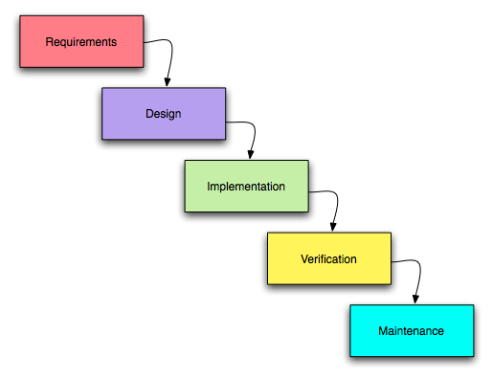

<https://eternalsunshineoftheismind.wordpress.com/2013/02/08/traditional-methods-of-software-development-the-waterfall-model/>

### **Pros and Cons:**

|  |  |
| --- | --- |
| **Pros** | **Cons** |
| The projects structure is easy to understand and straight forward | The method does not go back to previous phases making it harder and less flexible to go back to previous phases |
| The timeline is predictable | If I get stuck on one area for a long period of time it will affect the whole timeline for the subsequent phases. |
|  | Testing is delayed until after the website is created |

The waterfall method requires each phase to be completed before moving on to the next phase. This method works best when the requirements for the project are well known and defined and when the changes made to the project once it has started are small.

## **The Agile method**

The agile method is less straightforward than the waterfall method and focuses more on iterative improvement. The agile method involves breaking down the project into smaller and more manageable sections these sections are called sprints. The agile method allows for improvement and changes to be made to earlier sections on the product later on after they have been completed making it more flexible than the waterfall method.

Example of the agile method:

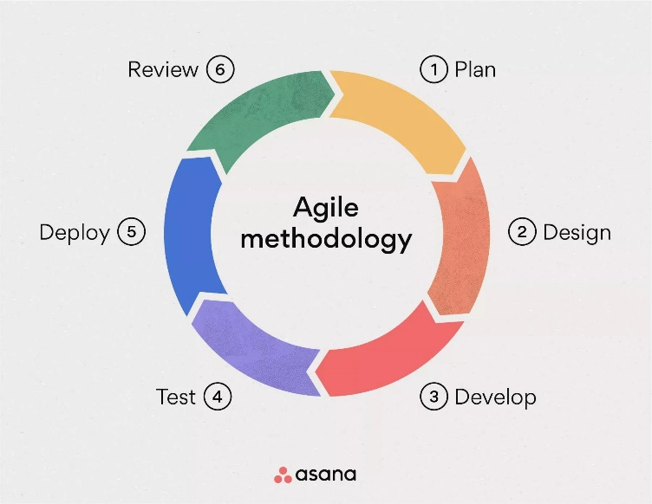

<https://medium.com/@olivernewman07/taking-lessons-from-software-engineering-implementing-agile-methodology-into-personal-development-2f097f12c79b>

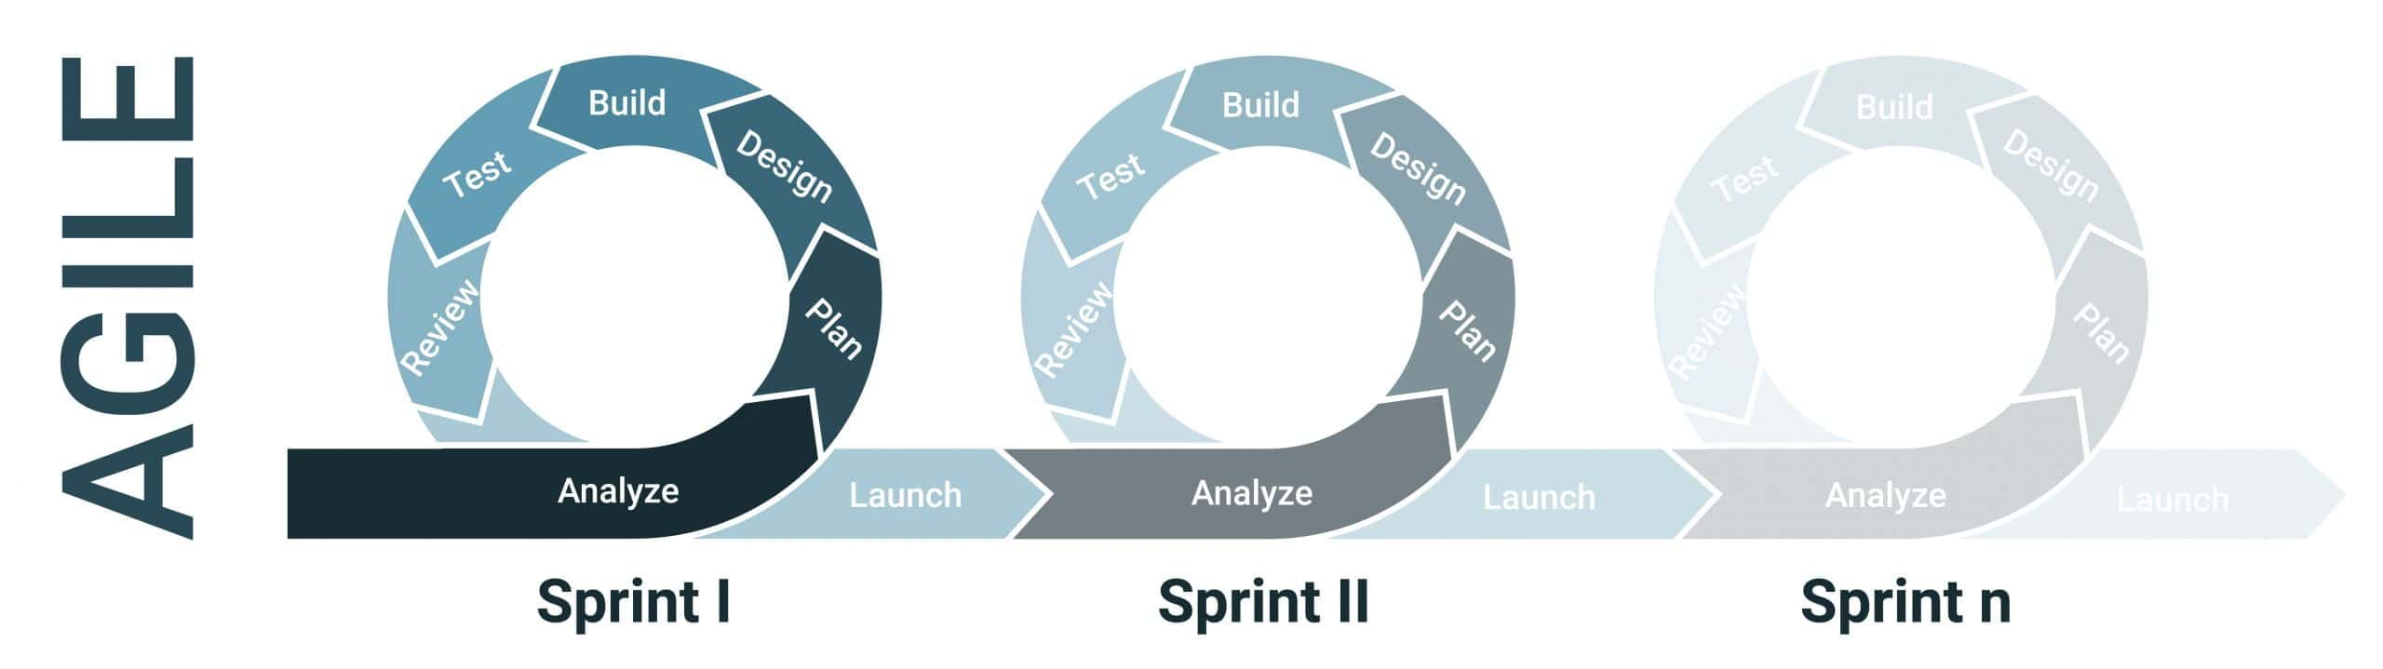

<https://www.discuss.io/blog/agile-approaches-consumer-insights/>

### **Pros and Cons**

|  |  |
| --- | --- |
| **Pros** | **Cons** |
| The requirements are adaptable and easier to change | The time required to complete the project is less predictable |
| Receives a lot more user feedback which helps it fit the user needs |  |

## **The scrum method**

The scrum method is a specific framework within the agile methodology. The scrum method uses sprints which are done within a certain timeframe and the goal of completing something which is agreed on in the planning phase. The scrum method adds roles to process with members of the team being assigned roles. The roles involved in the scrum method are the product owner, scrum master, and the development team. The product owner is in charge of laying out the features that the product will need and the goal of the sprint. The scrum master is in charge of managing the scrum process and making sure everything goes well. Finally, the development team is the group who develop the product. There are three main events in the scrum method these are the sprint planning, sprint review, and sprint retrospective. The sprint planning section is about planning the work that will be done in the sprint. The sprint review is about showing the results to the client and receiving feedback, and the sprint retrospective is about reflecting on the sprint and finding improvements that can be made in the next iteration. There are also other parts of the scrum method as well these are the product backlog, sprint backlog and the increment. The product backlog includes everything that needs to be done in the project. The sprint backlog includes everything that needs to be done during the sprint. The increment is the version that is completed after the sprint.

Example of scrum method:

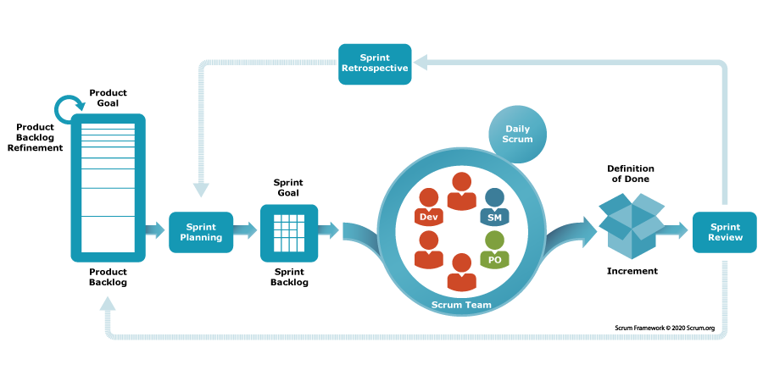

<https://sailingbyte.com/blog/agile-frameworks-in-software-development-scrum>

### **Pros and Cons**

|  |  |
| --- | --- |
| **Pros** | **Cons** |
| Provides a structure and set roles for a team | Requires specific roles which can be less flexible for some people |
| Receives lots of feedback from the client | If the product backlog is not managed well, it can cause the scope of the project to increase |
|  | If the client and users are slow to give feedback it can cause delays. |

# **Chosen Method**

Based on the methods that I have discussed I have reached the conclusion that I will be using the scrum method this is because I think this method works best for me. The waterfall method does not allow me to go back and iterate on previous sections and it receives less overall feedback than the scrum method. While the scrum method does have the downside of requiring more difficult management than the comparatively much simpler waterfall method, I will use a Gantt chart to make sure that I keep on track to finish on schedule. I think that the advantages of the scrum method overall outweigh the disadvantages when compared to the waterfall method because I will be able to manage the extra management and the extra feedback will be very useful for me. When comparing the scrum method to the agile method I think that I prefer the scrum method overall this is because I like the way that sprints are managed using the scrum method and I think it will be more effective for me. One disadvantage of the scrum method that could be an issue is if the client and users are slow to give feedback it could cause delays as well as that if they request more changes or features that could also add more work that will need to be done thus causing delays.

# **Tools for Decomposition**

Decomposition is the process of breaking the large overall project into smaller sections

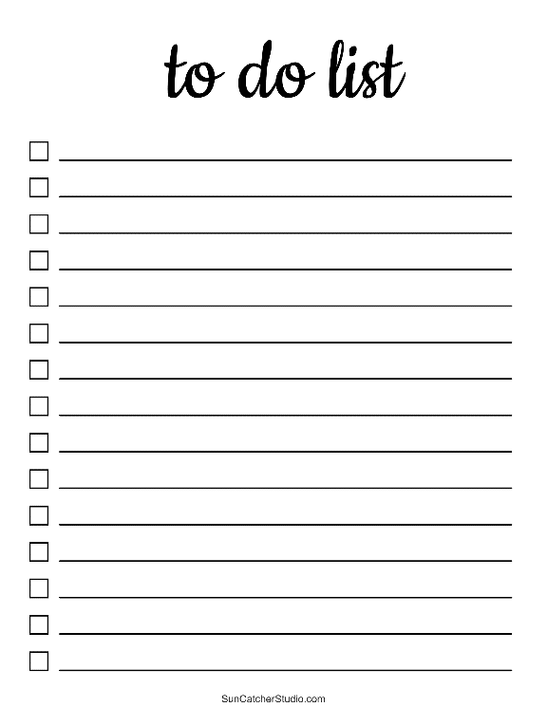

## **To do list:**

The to do list is probably the simplest way to break the project down into tasks. A to do list is simply just a list of tasks that need to be done.

<https://nz.pinterest.com/pin/475200198181647739/>

|  |  |  |
| --- | --- | --- |
| **Plus** | **Minus** | **Interesting** |
| Easy to create | Does not provide much extra information about what each thing is for | If you are a team, you must make sure everyone has access to the list |
| Easy to see what has been finished | To do lists that are made on paper are hard to share with others | As you work, you might want to cross off items but not delete them from the list, so you can see what has already been done |

## **Decomposition table:**

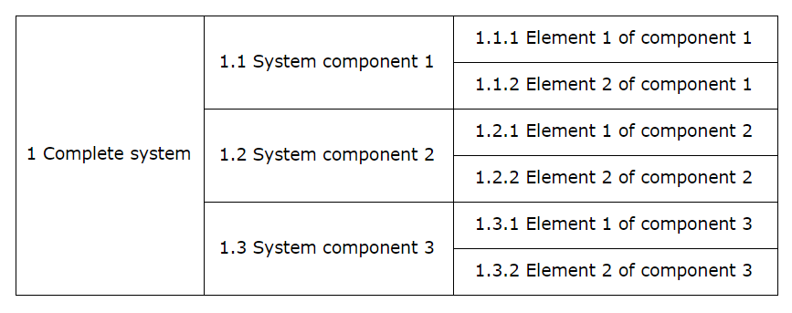

|  |  |  |
| --- | --- | --- |
| **Plus** | **Minus** | **Interesting** |
| Decomposition tables are tidy | Less visually appealing than a mind map | You must know how to insert and delete cells when tasks get updated |
| Every aspect of the project is accounted for, nothing will be left out |  |  |

## **Brainstorm / mind map:**

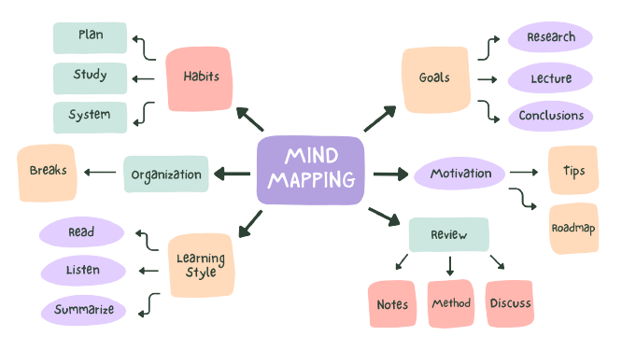

[**https://www.teamazing.com/mind-map/**](https://www.teamazing.com/mind-map/)

|  |  |  |  |
| --- | --- | --- | --- |
| **Plus** | **Minus** | **Interesting** |  |
| Most visually appealing | If done on a whiteboard thing can be erased | Colour can be used to categorise items |  |
| Easy to make |  | If you are a team, you must make sure everyone has access to the list |  |
| Shows the categories easily |  |  |  |

## **Chosen tool**

After considering the different tools I have decided that I am going to create a to do list for the decomposition and planning of the website. The reason I chose to use a to do list is because it is quick and simple, but it still shows the different aspects that I will need to work on. I can also cross out the sections that have been completed so I know what is done and still needs to be done this allows me to visually see how far through the project I am. I will also use a decomposition table so that I can format the tasks into different sprints and see what needs to be done.

# **To do list**

* Create navigation bar
* Create footer
* Create a root directory
* introduction section (Home page)
* NZ Culture section (Homepage)
* Other pages section (Home page)
* Introduction section (Māori culture page)
* information sections (Māori culture page)
* attractions section (Māori culture page)
* introduction section (north island page)
* natural and cultural section (north island page)
* gallery (north island page)
* attractions section (north island page)
* introduction section (South Island page)
* natural and cultural section (South Island page)
* gallery (South Island page)
* attractions section (South Island page)
* details (contact us page)

# **Decomposition table**

|  |  |  |
| --- | --- | --- |
| Complete system | Sprint 1 | Create a root directory |
| Create Navigation Bar |
| Create Footer |
| introduction section (Home page) |
| NZ Culture section (Homepage) |
| Other pages section (Home page) |
| Sprint 2 | Introduction section (Māori culture page) |
| information sections (Māori culture page) |
| attractions section (Māori culture page) |
| Sprint 3 | introduction section (north island page) |
| natural and cultural section (north island page) |
| gallery (north island page) |
| attractions section (north island page) |
| Sprint 4 | introduction section (South Island page) |
| natural and cultural section (South Island page) |
| gallery (South Island page) |
| attractions section (South Island page) |
| Sprint 5 | details (contact us page) |

This decomposition table does not include testing, trialling and validating code. It also does not include client and user feedback so; I will add that in a second iteration.

|  |  |  |
| --- | --- | --- |
| Complete system | Sprint 1 | Create a root directory |
| Create Navigation Bar |
| Create Footer |
| introduction section (Home page) |
| NZ Culture section (Homepage) |
| Other pages section (Home page) |
| Code validation |
| Testing and trialling |
| Client and user feedback |
| Sprint 2 | Introduction section (Māori culture page) |
| information sections (Māori culture page) |
| attractions section (Māori culture page) |
| Code validation |
| Testing and trialling |
| Client and user feedback |
| Sprint 3 | introduction section (north island page) |
| natural and cultural section (north island page) |
| gallery (north island page) |
| attractions section (north island page) |
| Code validation |
| Testing and trialling |
| Client and user feedback |
| Sprint 4 | introduction section (South Island page) |
| natural and cultural section (South Island page) |
| gallery (South Island page) |
| attractions section (South Island page) |
| Code validation |
| Testing and trialling |
| Client and user feedback |
| Sprint 5 | details (contact us page) |
| Code validation |
| Testing and trialling |
| Client and user feedback |

# **Planning and managing tools**

## **Calendar**

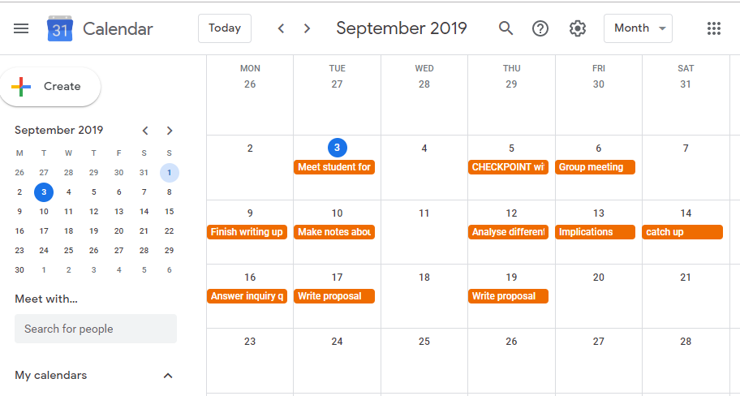

|  |  |  |
| --- | --- | --- |
| **Plus** | **Minus** | **Interesting** |
| Easy to see upcoming plans | Not much room to add detailed notes | Users should learn to use functions of online calendars, allowing them to create multiple calendars, show or hide selected calendars, select colours, add notes and set reminders. |
| Easy to plan and keep track of time | A paper calendar is difficult to share and carry around |  |
| Online calendars are easy to share with others in your project group. |  |  |

## **Gantt Chart**

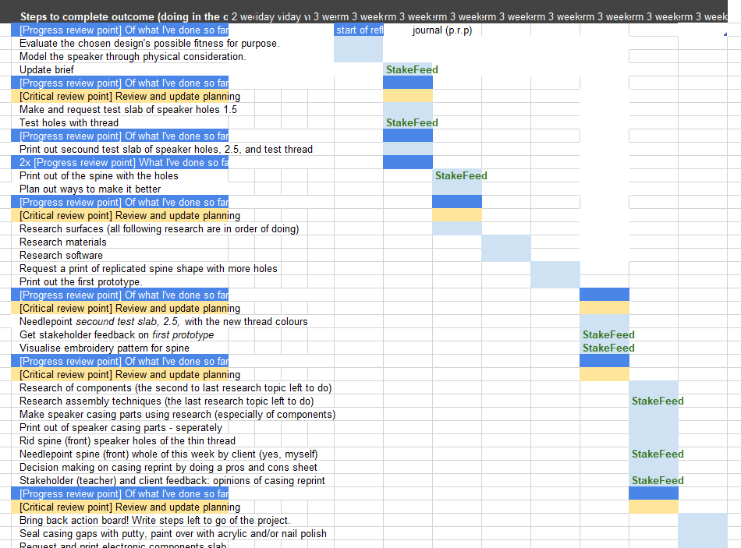

|  |  |  |
| --- | --- | --- |
| **Plus** | **Minus** | **Interesting** |
| Allows you to spread your time out evenly over the time allowed, avoiding a last-minute rush | Can get messy when updated if you aren’t careful | Can be updated as you work |
| Keeps track of time and easy to see what’s coming up |  | Often used in industry to manage complex projects |
| Can be used to show what tasks depend on the completion of others, and which can be carried out at the same time |  |  |

This is a chart used to allocate time to tasks in your project and is a good way of seeing an overview of the timeline. Dates go along the top and tasks down the side, then shading shows the proposed timing of tasks.

## **Scrum Board**

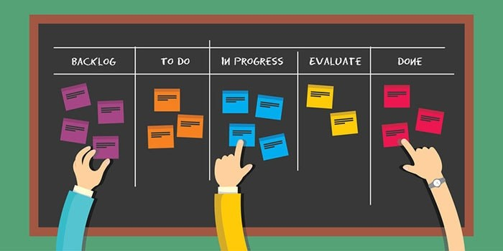

<https://visionateacademy.com/product/lean-agile-project-management/>

|  |  |  |
| --- | --- | --- |
| **Plus** | **Minus** | **Interesting** |
| Visually appealing | Not designed to show the timing of tasks but this can be added as a note | Often used in fast paced software industry and in agile project management. |
| Doesn’t get messy when updated because it is designed for flexibility and change |  | Pictures and notes can be easily added to tasks |
| Online version can be accessed anywhere from any device |  | If using GitHub, the project board is built in and you can add tags, link with issues etc. |
| Online version is easy to share |  | Can be organised by allocating tasks to people in the team, or colour coding types of task. |
| Easy to update |  |  |
| Keeps a record of completed tasks instead of deleting them because they are moved across |  |  |
| Easy for others to see where you are up to |  |  |

Scrum Board is a tool that helps make sprint backlog items visible. the board can take many physical and virtual forms, but it performs the same function regardless of how it looks. The board is updated by the Team and shows all items that need to be completed for the current Sprint.

## **Chosen tool**

I chose the Gantt chart because I can use it online easily and it is capable of managing my time so that I know what I am working on and when I should be finishing it. The reason I did not use calendar is because the Gantt chart can be used to do everything the calendar can but with extra features. I will also be making a scrum board before each sprint because it will allow me to plan out each sprint individually so that I know and can track everything being done in that sprint along with what has been completed. I will be using these two tools because they are easy to edit and help me stay on track and on schedule.

# **Gantt Chart**

To create my Gantt Charts, I used a website called Tom’s Planner. Gantt charts are important for helping to keep me on track this is because I can look at them and see if I am behind schedule, on schedule or ahead of schedule. Every week I will revisit my Gantt chart, if I am ahead of schedule or behind schedule, I will adjust the Gantt chart. As I finish sections I will change the colour of them to green to reflect them being completed. I will also use a different colour for the different sprints so that they can be differentiated on the Gantt chart.

**2/07/2024**

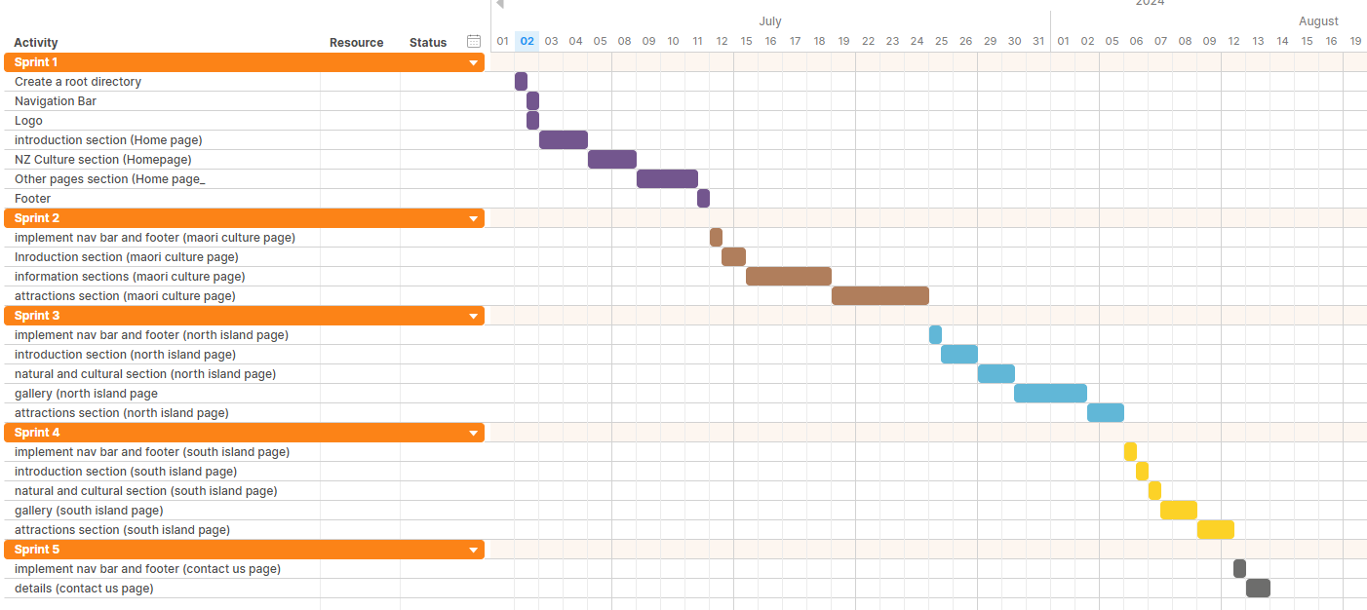

This is the first iteration of my Gantt chart I have added all the sprints and the parts that I expect to be involved in each sprint. I have colour coded all the sprints with different colours to make them easier to see. Sprint 1 is represented by the purple colour, sprint 2 is represented by the brown colour, sprint 3 is represented by the light blue colour, sprint 4 is represented by the yellow colour, and sprint 5 is represented by the grey colour. The length of time I have given myself for each section is based on how long I think it might take to do these actions.

**9/07/2024**

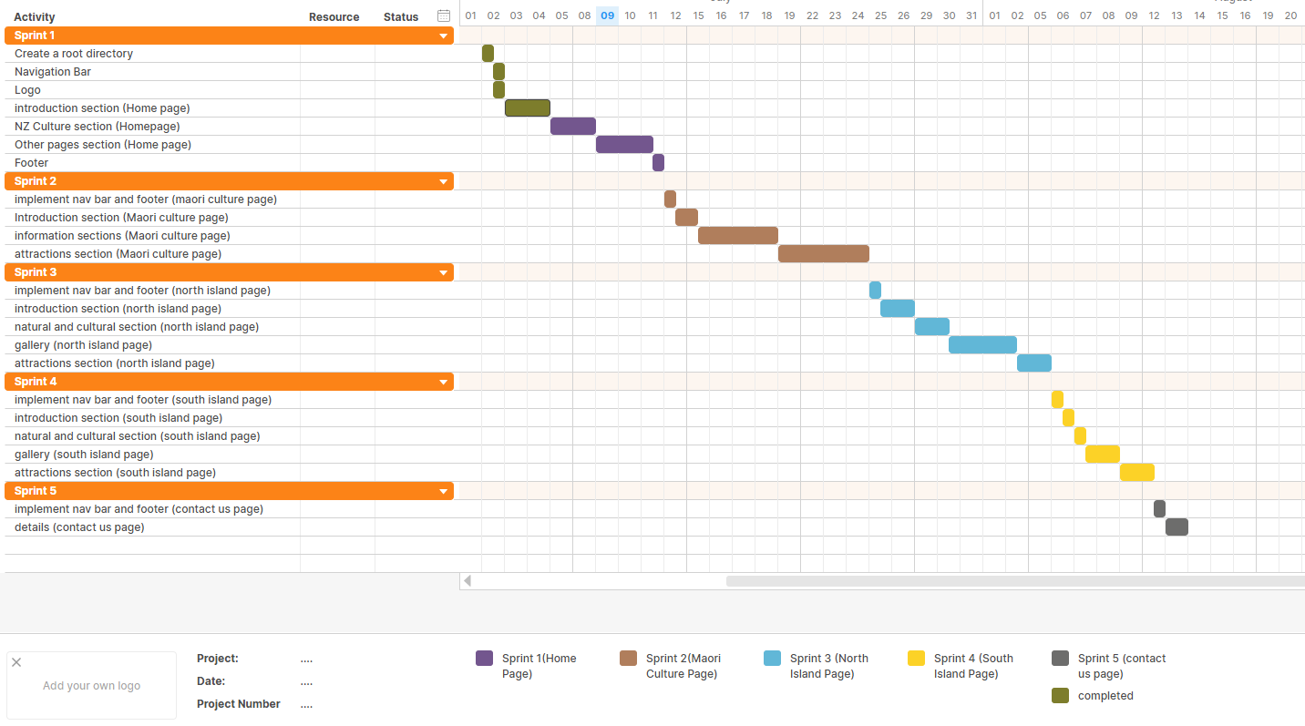

Here I have changed the colour of everything I completed to green however it is clear that I did not give myself enough time to complete the website so I will need to update the Gantt chart to give myself more time.

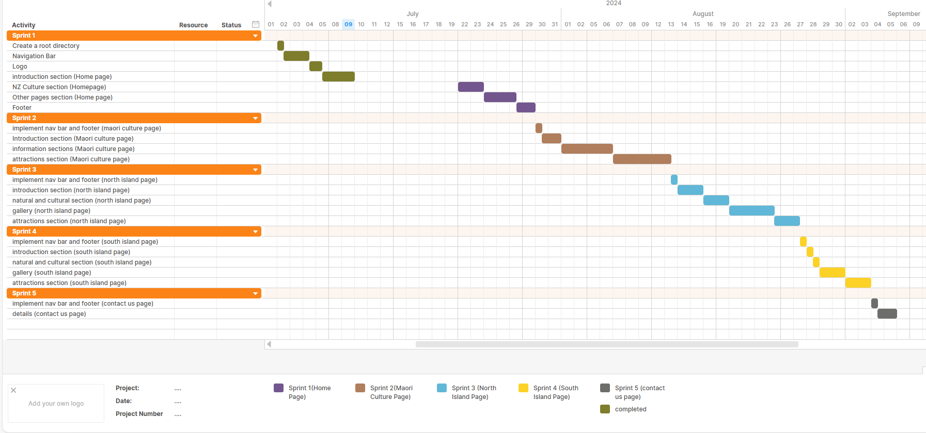

This is the second iteration of the Gantt chart I have given myself some extra time on most aspects of the development and I have moved everything back on the schedule this is because the school holidays have already started, and I do not know if I will continue to work on the website throughout the school holidays and If I do it will be very minimal.

**26/07/2024**

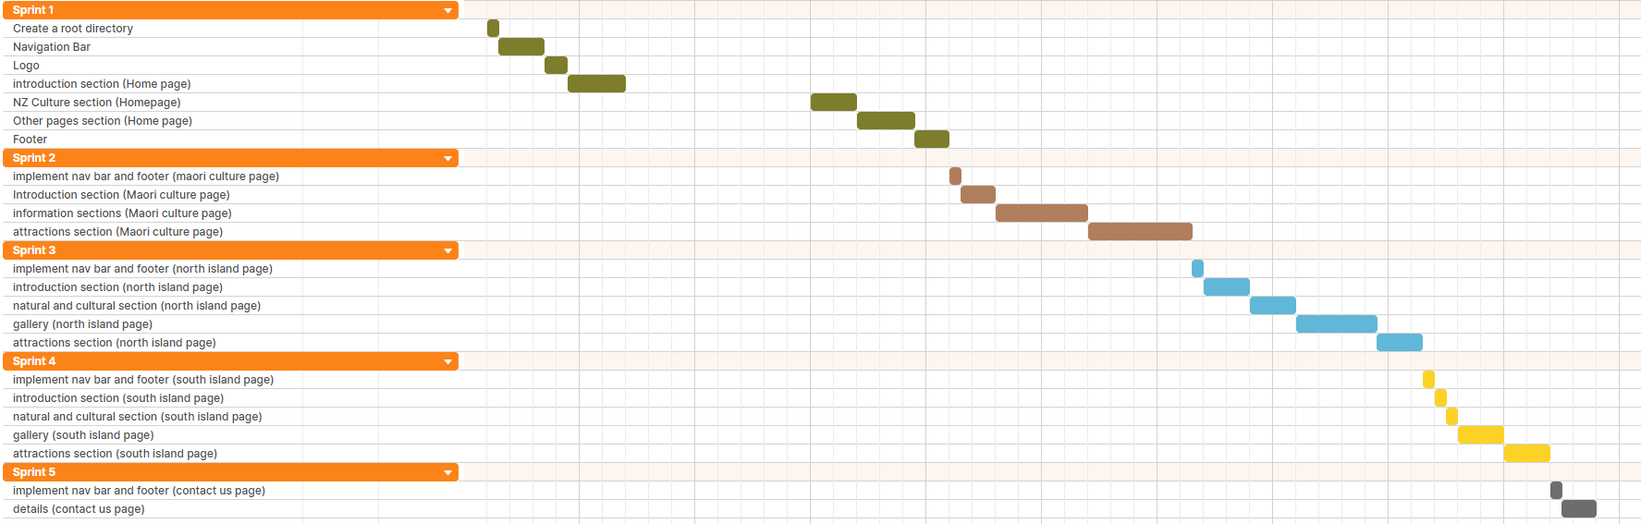

I have updated the colours of the Gantt chart by changing the completed components to green. I have completed my home page ahead of schedule and will begin working on my next sprint now.

**9/08/2024**

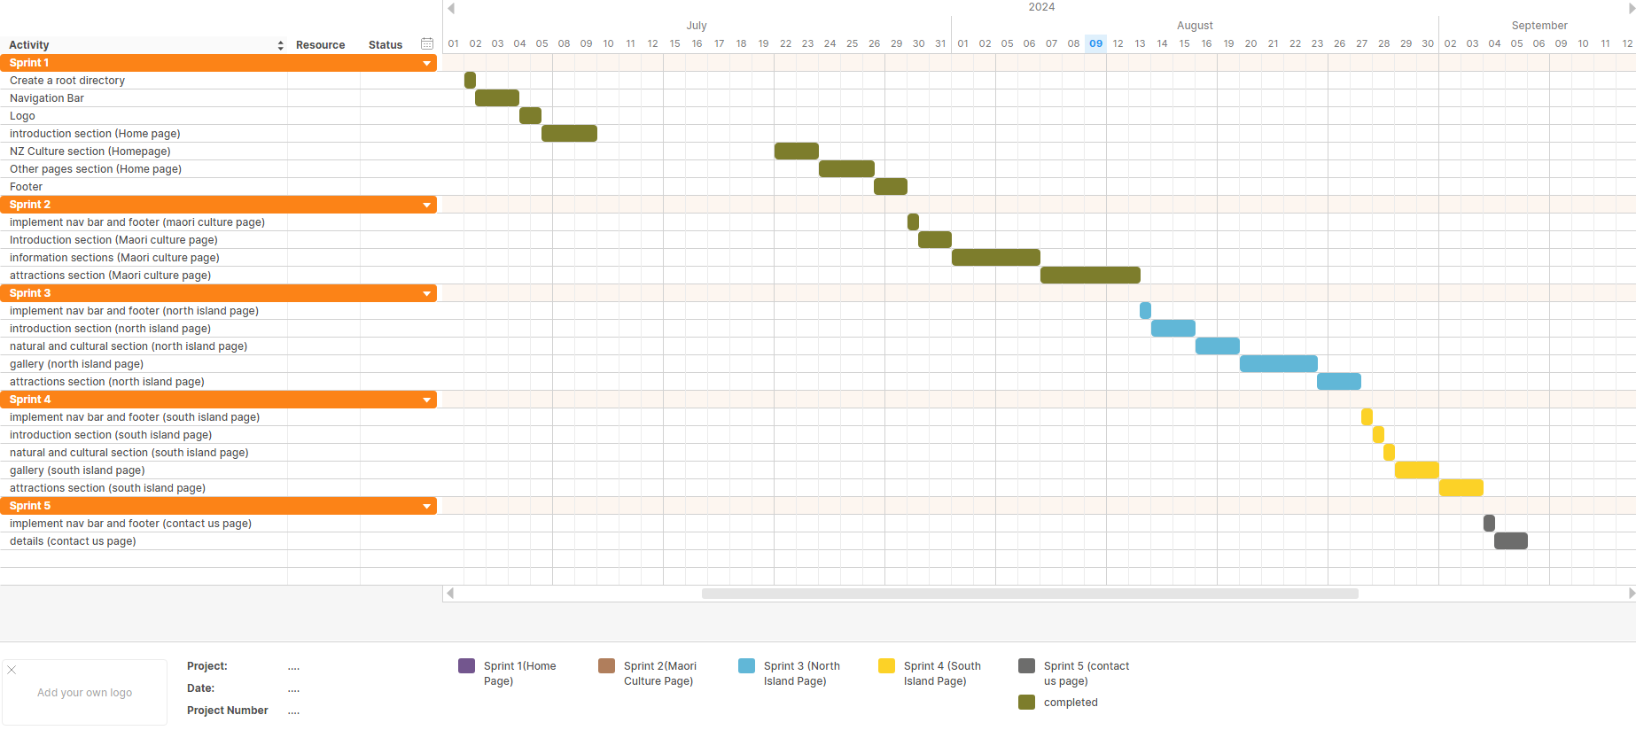

I have updated the colours of the Gantt chart by changing the completed components to green. I have completed this section of my Gantt chart ahead of schedule as I completed it on the 9th of August when I was expected to complete it on the 13th of August. I will not make any changes to the schedule for my next sprint, but it will give me some extra time to prepare for the next sprint.

**20/08/2024**

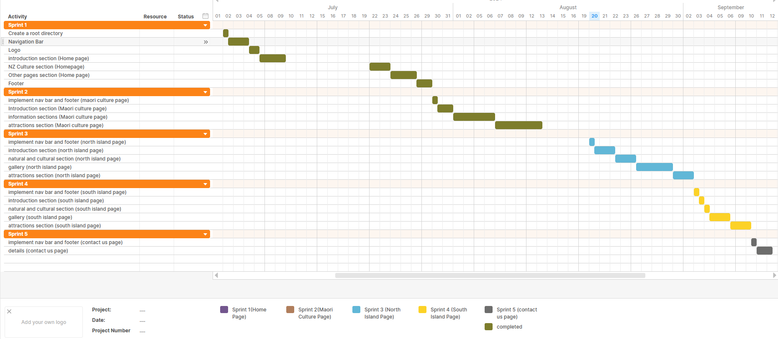

After completing the second sprint I needed to spend some time working on this visual diary and planning for my third sprint, although I did finish my second sprint early, I ended up spending a long time working on this visual diary which has caused me to delay starting the third sprint until today. I have moved back the schedule so that I can start now.

**1/09/2024**

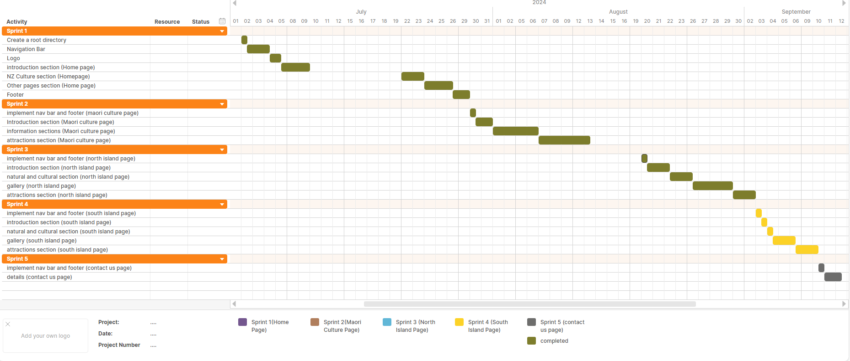

I have completed my third sprint, and I have updated the colours of the Gantt chart by changing the completed components to green. I have not made any other changes to the Gantt chart and the schedule remains the same.

**7/09/2024**

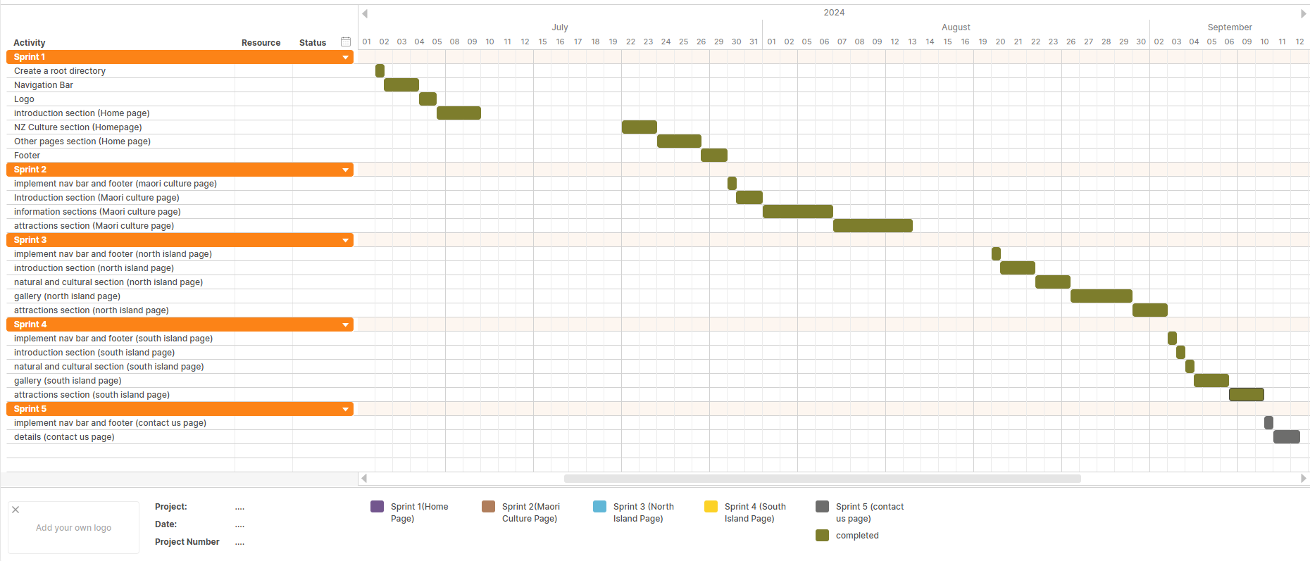

I have updated the colour of the Gantt chart to show the sections that I have completed so far. I have finished my fourth sprint early.

**11/09/2024**

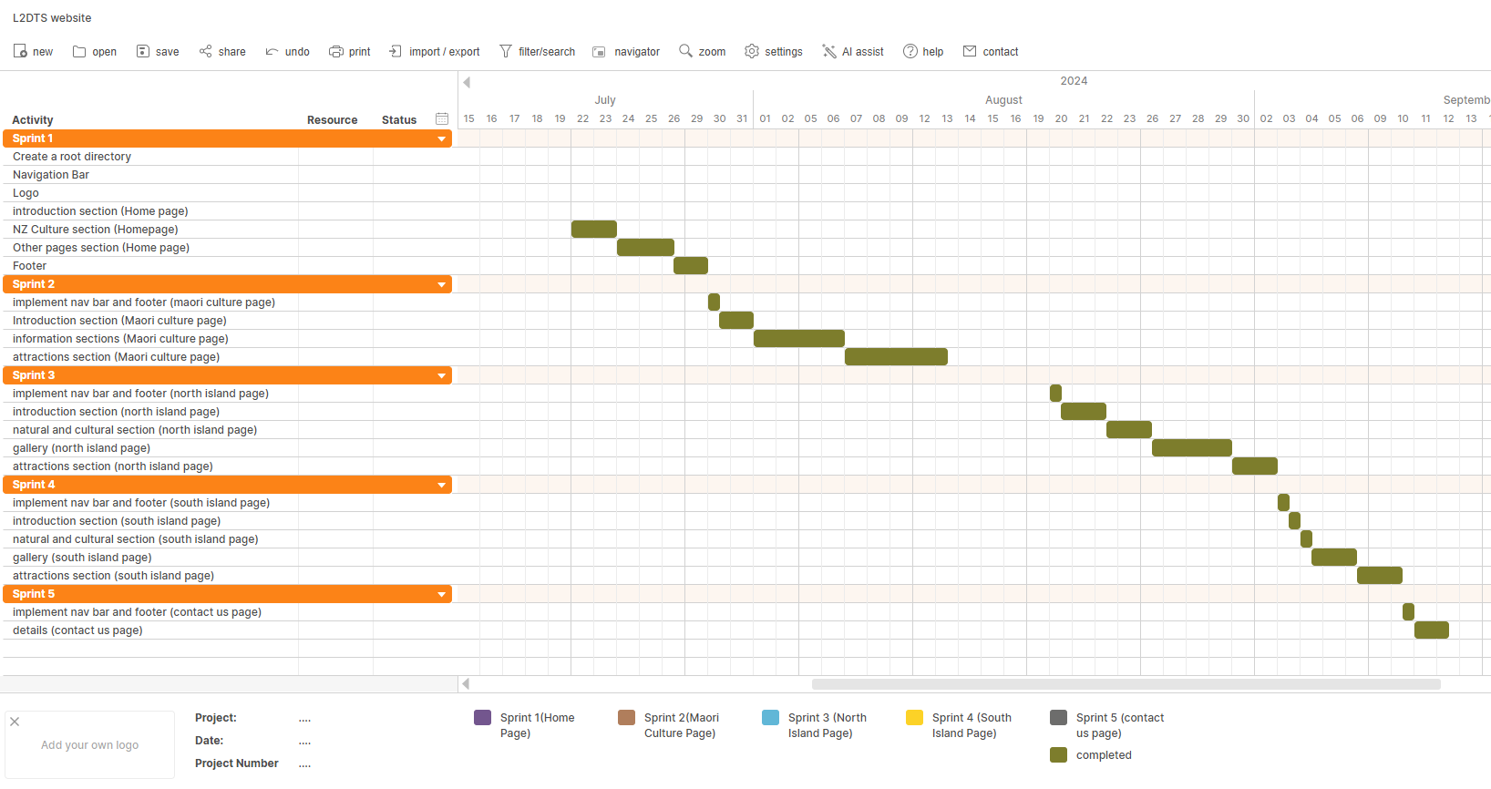

I have now completed my 5th sprint along with everything on my Gantt chart. I completed my project 1 day ahead of schedule as I expected to finish my project on 12/09/2024. Everything on the Gantt chart is now coloured green to represent that they have been completed.

# **Sprint 1 (Home Page)**

## **Scrum board**

Before starting the first sprint I planned out all the aspects that would be involved in the making of the website and then created a scrum board for the first sprint where I would move the parts that I would work on in the first sprint from the product backlog to the sprint backlog. As I begin working on the sprint, I will move the parts I am working on to the in-progress section and then to the done section when I am finished with that section.

This is the first version of the scrum board everything that will be focused on in this sprint has been placed in the sprint backlog as the sprint progress the scrum board will be updated with a date to show how the sprint is progressing.  
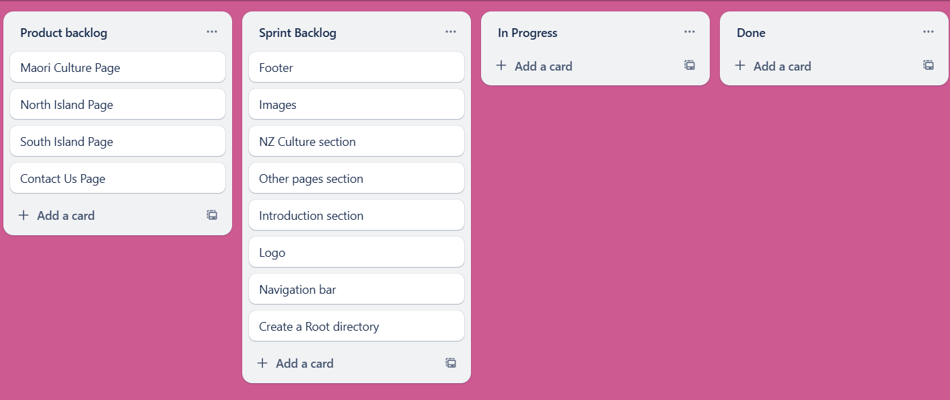

2/07/2024

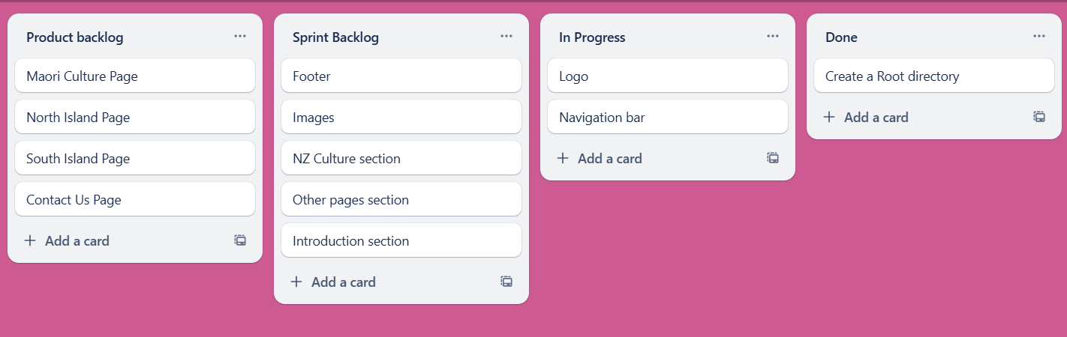

This is the scrum board as of 2/07/2024 the first thing that I am working on is the navigation bar and the logo for the website. I have already created a root directory

4/07/2024

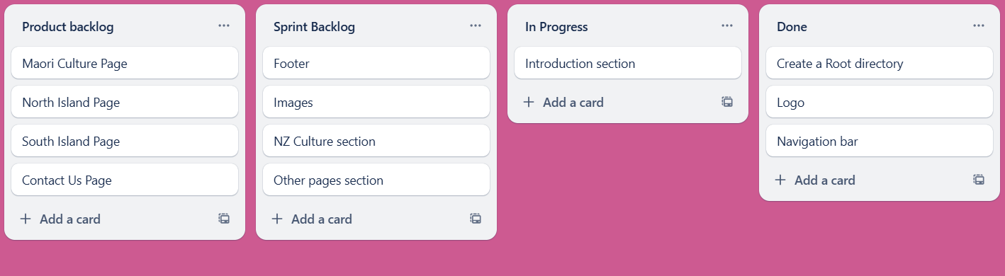

This is the scrum board as of 4/07/2024. I have completed the logo and navigation bar, so I have moved them to the “done” section. I will now begin working on the introduction section.

26/07/2024

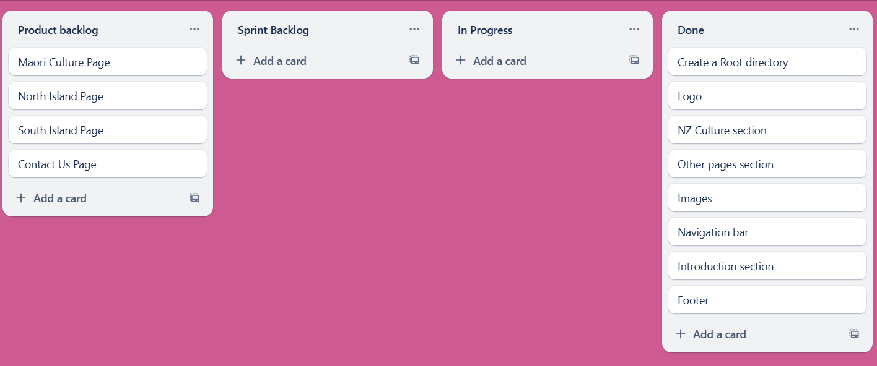

This is the scrum board as of 26/07/2024.I have come back from the school holidays at the end of the term (which is why there is a large gap between updates), and I have completed all the items in the sprint backlog and moved them to the “done” section.

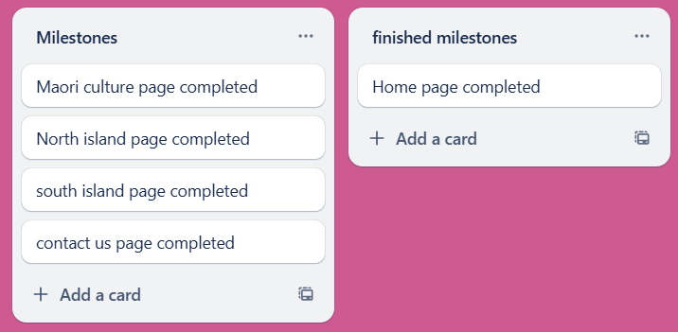

This also means that I have completed the first milestone for the project.

## **Debugging**

**Error:**

Logo appears above the navigation bar instead of next to it.  


**Fix:**

Aligning the links to the centre of the screen.



**Error:**  
Logo is too small and shrinks when the screen is zoomed out this means it is not consistent in different screen sizes and it is hard to see.



**Fix:**



Height was set to 40 pixels which caused it to appear smaller on larger screens. I fixed this issue by setting the height using percentages.

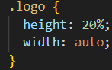

At first this did not work which I discovered was because the width was set to auto so I changed the width to a percentage as well which fixed the issue

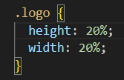

Now the logo remains the same size no matter what the size of the screen is as it takes up the same percentage of space.



This change has not been applied to the links yet.

**Error**

When the logo is click it does not take the user to the home page.

**Fix:**



I added a href tag that will take the user to the home page when the logo is clicked. This fixed the issue, but it broke the CSS that controlled the size of the logo.



I was able to fix the size of the image by editing the relevant CSS.  
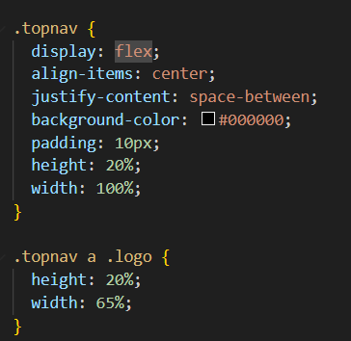

I added height and width attributes to the topnav section which allowed me to alter the size of the logo which I could not do before because the size of the parent topnav had not been defined.



## **Trialling**

|  |
| --- |
| **Component:**  Navigation bar font  **Trial 1:**  A black background with white text  Description automatically generated  Serif font  **Trial 2:**    Arial Font  **Trial 3:**    Bahnschrift font  **Decision:**  I have decided to use the bahnschrift font because it looks bolder for the links. Bahnschrift was also the font that was the most popular during my font research. |
| **Component:**  Nav bar link hover  **Trial 1:**    Red background behind the link  **Trial 2:**    Link Underline  **Decision:**  I have decided to use the link underline from trial 2because it is more simplistic than the red background link. The client and user feedback that I received did not like the red background, so I think it is better to replace it with this. |
| **Component:**  Button  **Trial 1:**    No corner rounding  **Trial 2:**    15px corner rounding  **Trial 3:**    25px corner rounding  **Decision:** After asking my client which button they preferred we decided to use the trial 2 with 15px of corner rounding the reason for this is because trial 1 with no corner rounding was too square and my client preferred the more subtle corner rounding on trial 2 compared to trial 3. |

## **User and Client Feedback**



After completing the navigation bar, I gave it to my client and user to give feedback to.

Client Feedback:

Increase the size of the logo and also increase the size of the links and make them spread out more.

User Feedback:

I don’t like the red that shows up when you hover on a link or for the page you are on.



I have applied the user feedback by increasing the size of the links, and logo, I have also replaced the red with an underline that shows the user what page they are on and what link they are hovering over.



When the user clicks the image to navigate to a new page it will open the new page in a new tab.

Client Feedback:

It’s better if it opens on the same tab instead of opening a new one

User Feedback:

I don’t like it if it takes me to a new page because it is less convenient



Clicking the link now loads the new page on the same tab instead of opening a new tab. I applied the feedback that my client and user gave. I did this by adding a target= “_self” to the images so that I opens in the same page.

## **Testing**

|  |  |  |
| --- | --- | --- |
| **Number** | **Test** | **Evidence** *(screenshots, including before and after for iterative)* |
| **1** | All content must be readable | My website uses large font sizes which makes it easy for the user to read all the text on the website. |
| **2** | Navigation must work (No broken links) | All links on my website link to other pages successfully. I have checked every link including my logo and they all successfully link to the desired page. |
| **3** | Images displayed correctly, **optimised for the web**- alt | All images on my website have alt tags this means that if the image fails to load it will display a text telling the user what the image is. |
| 4 | No error in mark up or CSS (Validator evidence) | A screenshot of a phone  Description automatically generated   Originally my code had two errors and one warning. I have fixed all errors and warnings that appeared. |
| 5 | Browser testing | I tested my website using chrome and Microsoft edge |
| 6 | All pages of your site are understandable and easy to use | I conducted user testing and fixed any problems they had my client, and the users did not have any problems understanding and using the website |
| 7 | There is an access to the Main menu from all pages | There is a navigation bar that allows the user to access the home page and if the user clicks on the logo in the top left or in the footer then it will also return the user to the home page |
| 8 | There are no grammar and spelling mistakes. The data is typed correctly without errors | I have checked all my spelling and there are no spelling or grammar errors present. |
| 9 | Images are placed properly with proper size (No stretching etc) | The images in my website are placed correctly where they are intended to be, and they display without stretching. |
| **10** | Content should be informative, understandable, structured and logically linked | I have added all the text to my website it is understandable and structured to have a purpose |
| **11** | Evidence of design elements: layout, colours, fonts, font sizes, labels, text boxes, text formatting, captions, buttons, lists, icons, links | This website uses large font sizes to make all the content easily readable for everyone, I am using the font Bahnshrift as that was the font that was decided on in my font research during the conceptual. The text in my website is centred. My website has a button and links in the nav bar, it does not have any lists. My website generally uses a black and white colour scheme however the images do provide colour to the website. |
| **12** | Code commenting is helpful | In my code I use code commenting to label the sections of my code so that I know what part corresponds with each part of the website |
| **13** | alt text for all images and it matches the image | All images in my code have alt text attributed to them that match the image |
| **14** | All information included | All information is included in the home page |
| **15** | All pages have a consistent look and feel | I have only created the home page however I intend to give all pages a consistent look and feel based on the wireframes / high fidelity I created in the conceptual |
| **16** | All files saved in one folder (sub folders if needed) | Everything is saved in the same folder    All images are saved in a sub folder called home-images |
| **17** | Files and folders named correctly (no spaces, capitals, well named) | All files do not include spaces. Some files include capital letters for names, but this has been changed. |

## **Code Validation**

These are the errors in my html code for home.html

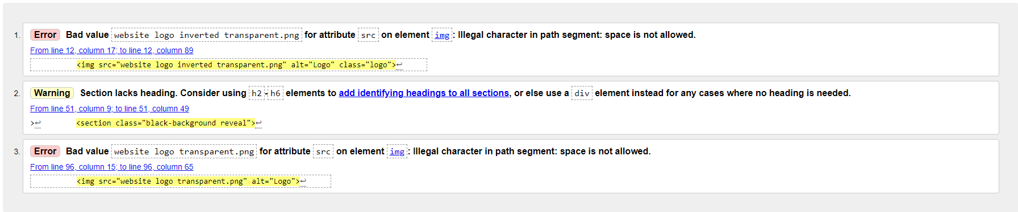



This is the first error in my code it is caused by spaces being used in the path for an image.

Code before:



Code after:



The error has been fixed I did this by changing the name of the file to not include spaces so that the path did not include spaces.

2.



This error occurred twice so I did the same thing to fix this error

3.



Code before:



Code after:



I fixed this error by changing the section to a div.



# **Sprint 2 (Māori Culture Page)**

## **Scrum Board**

Before starting the second sprint I planned out all the aspects that would be involved in this sprint and placed them in the sprint backlog. I decided I would use this sprint with the goal of completing the Māori Culture page for my website.

This is the first version of the scrum board everything that will be focused on in this sprint has been placed in the sprint backlog as the sprint progress the scrum board will be updated with a date to show how the sprint is progressing.

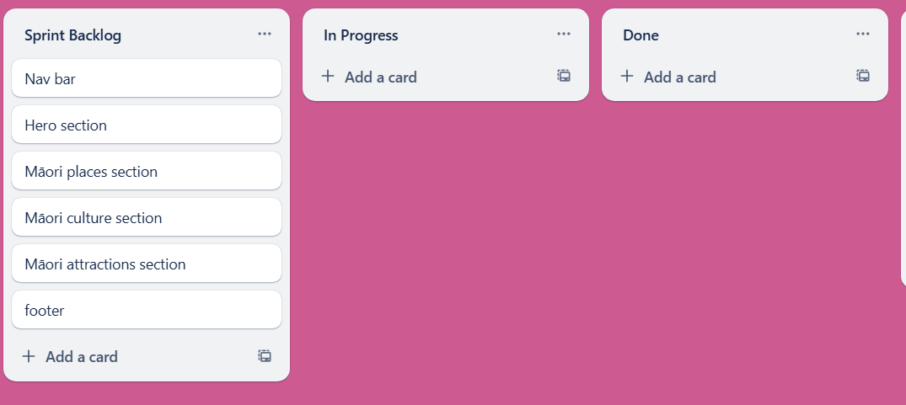

01/08/2024

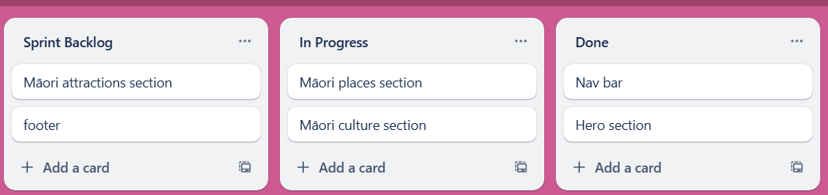

This is the scrum board as of 01/08/2024. I have completed the navigation bar and hero section, and I am currently working on the Māori places and culture section of the web page.

09/08/2024

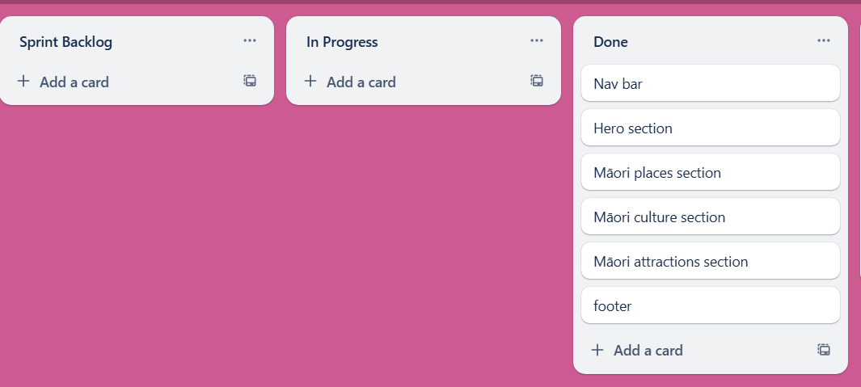

This is the scrum board as of the 9th of August 2024 I have completed the Māori attractions section and the footer of the web page. This means that I have completed everything in my sprint backlog, and I have completed the Māori culture web page for my website.

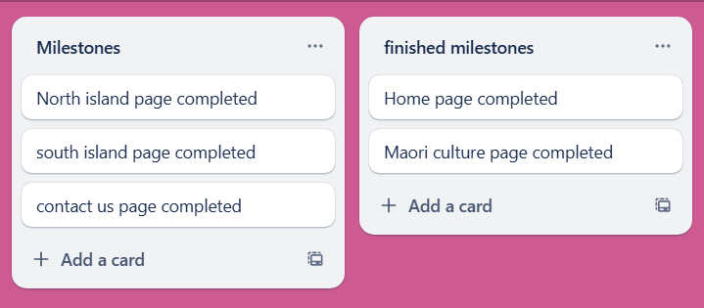

This means that I have completed another milestone for my project.

## **Trialling**

|  |
| --- |
| **Component:**  White space  **Trial 1:**  No white space at the bottom  **Trial 2:**    White space at the bottom  **Decision:** I will use white space at the bottom of the attractions section because it helps separate the section from the footer below it. |

## **User and Client Feedback**

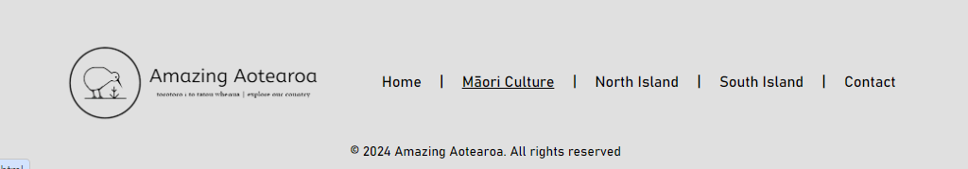

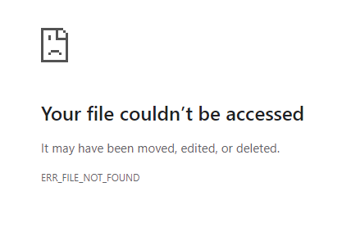

The link in the footer does not work.

Code fix:



I have fixed the link, and it works now.

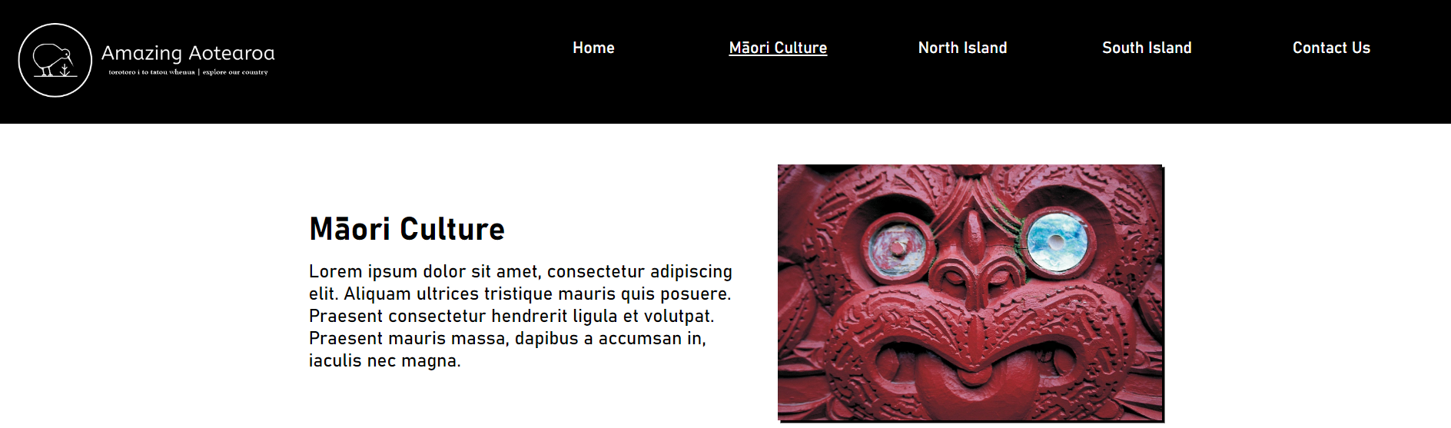

## **Testing**

|  |  |  |
| --- | --- | --- |
| **Number** | **Test** | **Evidence** *(screenshots, including before and after for iterative)* |
| **1** | All content must be readable | The font and font sizes that I am using is easy to read and users have not had any trouble seeing the text. I have not added the proper text to website yet as I have used a placeholder lorem ipsum text, but I will add the real text later. |
| **2** | Navigation must work (No broken links) | All links on my website link to other pages successfully. I have checked every link including my logo and they all successfully link to the desired page. |
| **3** | Images displayed correctly, **optimised for the web**- alt | All images on my website have alt tags this means that if the image fails to load it will display a text telling the user what the image is. |
| 4 | No error in mark up or CSS (Validator evidence) | A screenshot of a computer  Description automatically generated  Originally my code had 4 errors and 1 warning that I needed to fix but I fixed these errors and there are no more errors or warnings.  A green rectangle with black text  Description automatically generated |
| 5 | Browser testing | I tested my website using Google Chrome and Microsoft Edge and it worked on both browsers. |
| 6 | All pages of your site are understandable and easy to use | I conducted user testing and fixed any problems they had my client, and the users did not have any problems understanding and using the website |
| 7 | There is an access to the Main menu from all pages | There is a navigation bar that allows the user to access the home page and if the user clicks on the logo in the top left or in the footer then it will also return the user to the home page |
| 8 | There are no grammar and spelling mistakes. The data is typed correctly without errors | I have checked all my spelling and there are no spelling or grammar errors present. |
| 9 | Images are placed properly with proper size (No stretching etc) | The images on my website are placed correctly where they are intended to be, and they display without stretching. |
| **10** | Content should be informative, understandable, structured and logically linked | All the elements on my website are structured and understandable. |
| **11** | Evidence of design elements: layout, colours, fonts, font sizes, labels, text boxes, text formatting, captions, buttons, lists, icons, links | This website uses large font sizes to make all the content easily readable for everyone, I am using the font Bahnshrift as that was the font that was decided on in my font research during the conceptual it also is consistent with the other page from sprint one. The text in my website is centred. My website has buttons and links in the nav bar, it does not have any lists. My website generally uses a black and white colour scheme however the images do provide colour to the website. |
| **12** | Code commenting is helpful | I use code comments throughout my code to show me which parts of the code correspond with each part of the web page |
| **13** | alt text for all images and it matches the image | All images in the code have alt tags attributed to them which match the image. |
| **14** | All information included | I have completed most of the content in the web page, but I have not included all the text yet and I am currently using lorem ipsum text, but I will add the real text later. |
| **15** | All pages have a consistent look and feel | I have created 2 pages so far these are the home page and Māori culture page they have a consistent look and feel as they are both created using the wireframes / high fidelity that I made in my conceptual I also intend on making the other pages look and feel consistent with these 2 pages |
| **16** | All files saved in one folder (sub folders if needed) | Everything is saved in the same folder    All images are saved in a sub folder called home-images |
| **17** | Files and folders named correctly (no spaces, capitals, well named) | All files do not include spaces or capitals. The files all use names that relate to them. |

## **Code Validation**

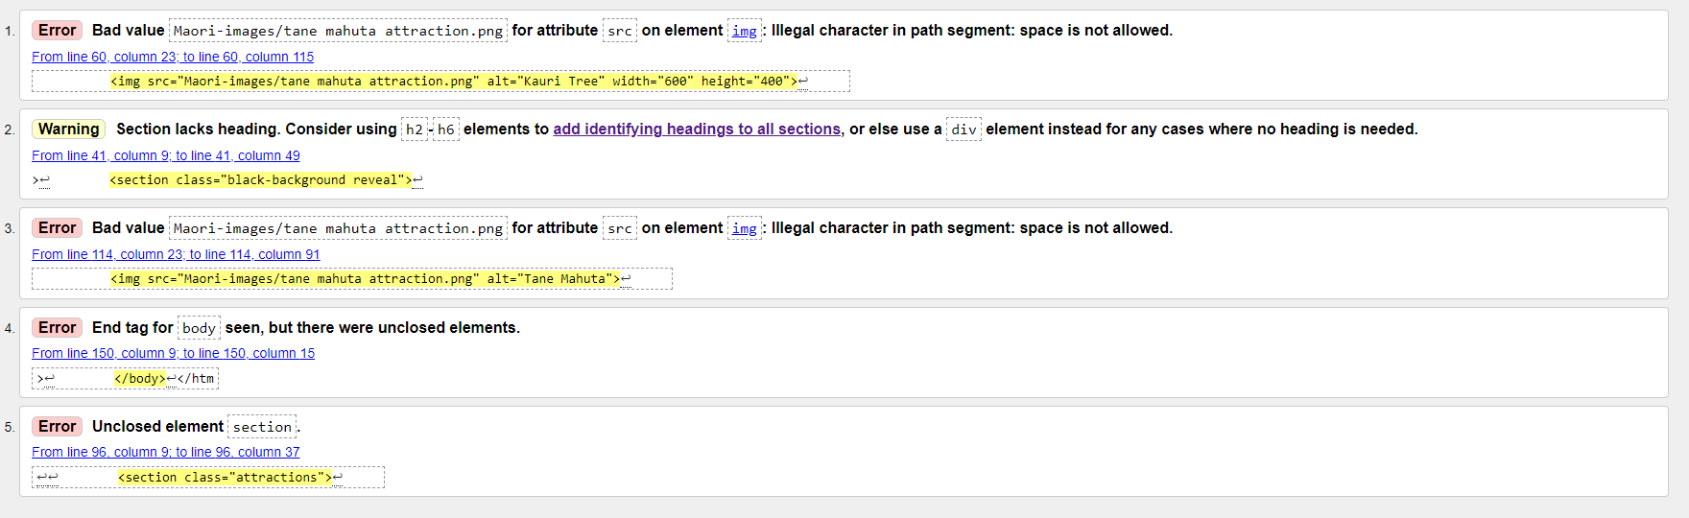

The code for my Māori culture page had 4 style errors and 1 warning which I will need to fix

1.



Code before:



This is the code before I have identified the problem is caused by my path including spaces.

Code after: 

I have fixed this error by removing the spaces and replacing them with a hyphen.

2.



Code before:



Code after:



I fixed this warning by switching the section tag to a div tag.

3.



Code before:



This error is the same as the first error it is caused because my image path has a space in it.

Code after:



I have fixed this error the same why by replacing the spaces with hyphens

4 and 5.





The fourth and fifth error is caused by an element in my body being unclosed.



I have located the section that I had not closed, and I have added a tag to close it.



There are no more errors in my code

# **Sprint 3 (North Island Page)**

## **Scrum Board**

Before starting my third sprint I have moved all the items I need to add to the sprint backlog. The goal of this sprint is to complete the North Island page which includes attractions that are located within the North Island.

This is the first version of the scrum board  
**20/08/2024**

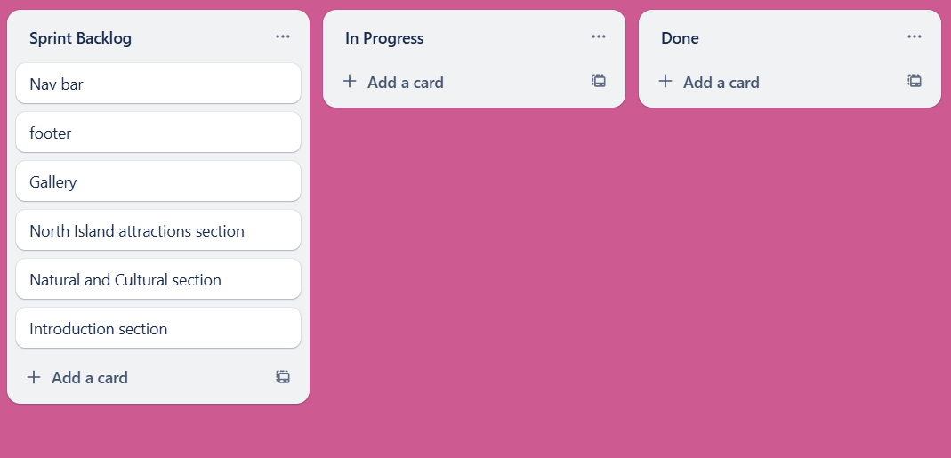

**22/08/2024**

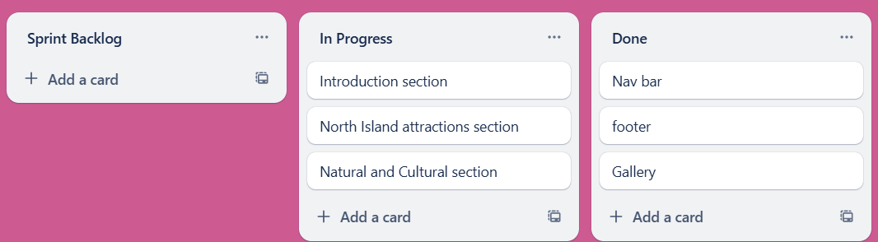

This is the scrum board as of 22/08/2024 I have been working on north island page and I have made good progress. I have transferred over the footer and nav bar to this page and I have managed to complete the gallery a lot quicker than expected by doing a lot of work outside of class this means that I just have to complete the introduction section, north island attractions section and the natural and cultural section. I was originally supposed to develop the introduction section along with the natural and cultural section before I started the gallery section, but I decided to work on the gallery section first because it is the hardest so by completing it, I will be able to create the rest a lot quicker.

1/08/2024

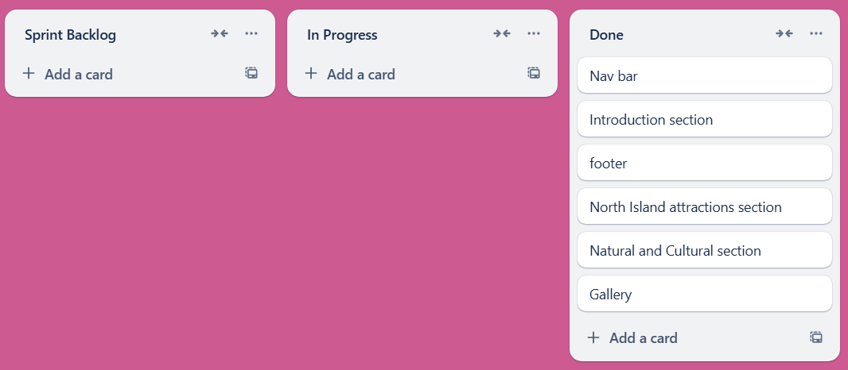

This is the scrum board as of 1/09/2024 I have completed the remaining parts of the sprint backlog meaning that I have completed the north island page.

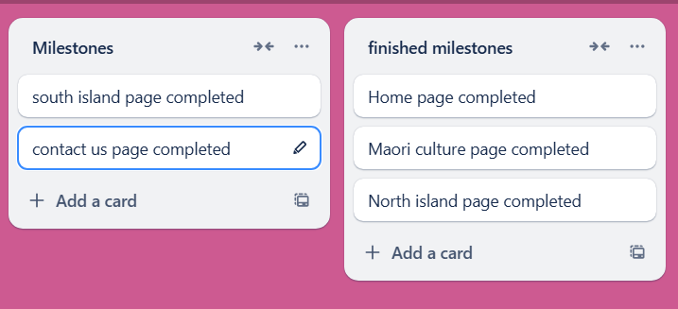

This means that I have completed another milestone

## **Trialling**

|  |
| --- |
| **Component:**  Gallery image  **Trial 1:**    Fixed image  **Trial 2:**    Parallax image scrolling  **Decision:**  I have decided to use the parallax image scrolling. I cannot show what the scrolling looks like using screenshots but after getting opinions from users and my client I determined that it look more visually appealing. |
| **Component:**  Gallery button  **Trial 1:**    Gallery button in the centre of the image.  **Trial 2:**    Gallery button at the bottom.  **Decision:**  Overall people liked the appearance of having the button at the bottom of the image because they believed it looked better and it can be seen even after scrolling further down. |
| **Component:**  Natural and cultural section paragraphs  **Trial 1:**    Black text  **Trial 2:**    Grey text  **Decision:**  I will be using black text because the users said that it was more readable. |

## **User and Client Feedback**

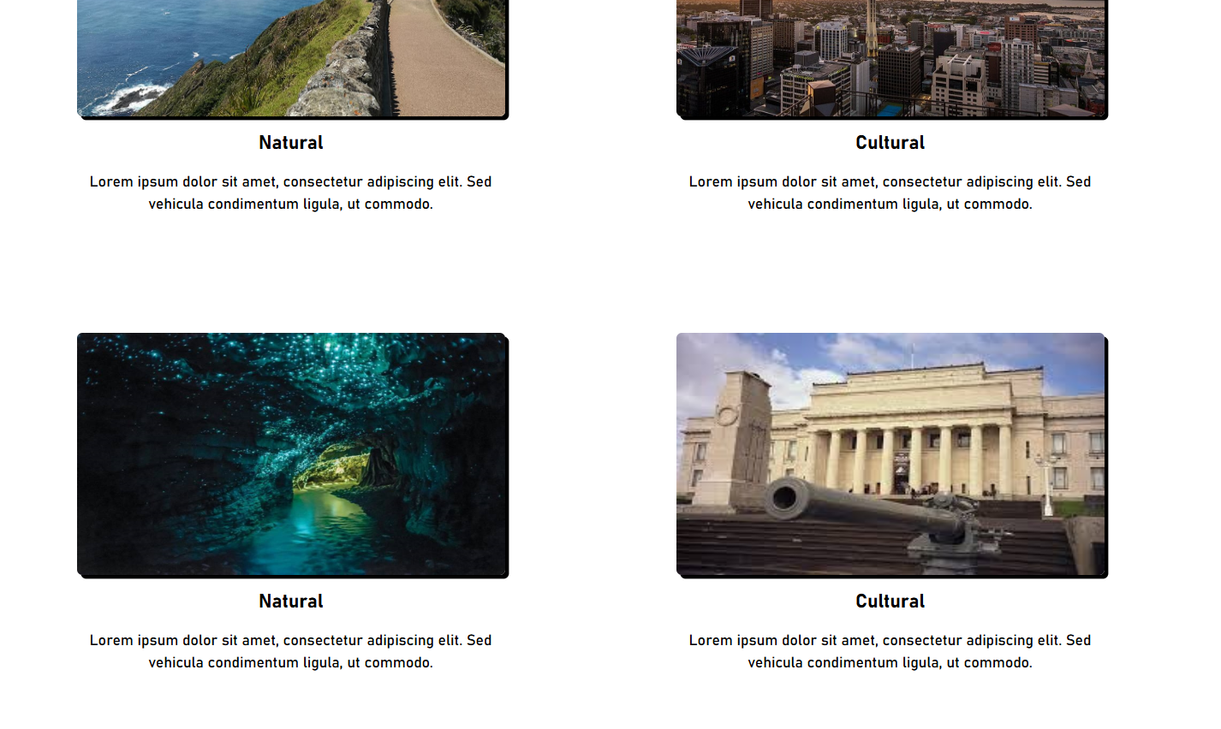

I received feedback from users that the header for the natural and cultural section were too small and I should make it larger.

Code before:

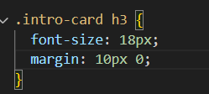

Code after:

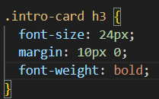

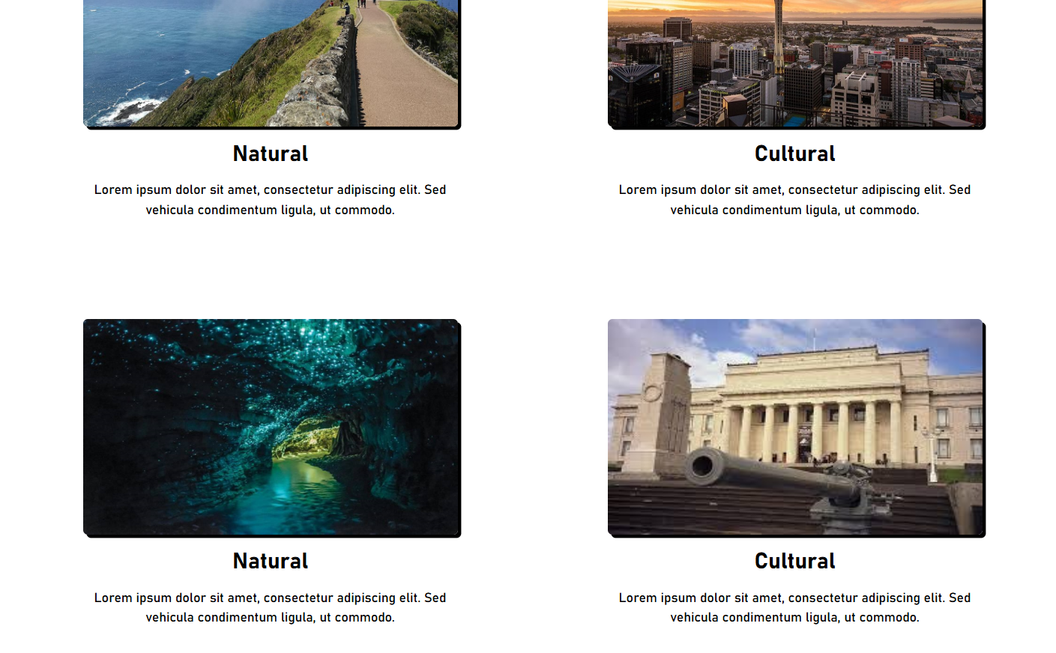

The headers are now bold and a larger font size

## **Testing**

|  |  |  |
| --- | --- | --- |
| **Number** | **Test** | **Evidence** *(screenshots, including before and after for iterative)* |
| **1** | All content must be readable | I have done user testing on the north island page and every user has been able to read all the content on the page without having any issues. |
| **2** | Navigation must work (No broken links) | All links on my website link to other pages successfully. I have checked every link including my logo and they all successfully link to the desired page. |
| **3** | Images displayed correctly, **optimised for the web**- alt | All images on my website have alt tags this means that if the image fails to load it will display a text telling the user what the image is. |
| 4 | No error in mark up or CSS (Validator evidence) | My code did not have any errors or warnings in it. |
| 5 | Browser testing | I tested my website using Google Chrome and Microsoft Edge and it worked on both browsers. |
| 6 | All pages of your site are understandable and easy to use | I conducted user testing and fixed any problems they had my client, and the users did not have any problems understanding and using the website |
| 7 | There is an access to the Main menu from all pages | There is a navigation bar that allows the user to access the home page and if the user clicks on the logo in the top left or in the footer then it will also return the user to the home page |
| 8 | There are no grammar and spelling mistakes. The data is typed correctly without errors | I have checked all my spelling and there are no spelling or grammar errors present. |
| 9 | Images are placed properly with proper size (No stretching etc) | The images on my website are placed correctly where they are intended to be, and they display without stretching. |
| **10** | Content should be informative, understandable, structured and logically linked | All the elements on my website are structured and understandable. |
| **11** | Evidence of design elements: layout, colours, fonts, font sizes, labels, text boxes, text formatting, captions, buttons, lists, icons, links | This website uses large font sizes to make all the content easily readable for everyone, I am using the font Bahnshrift as that was the font that was decided on in my font research during the conceptual it also is consistent with the other page from sprint one and two. The text in my website is centred. My website has buttons and links in the nav bar, it does not have any lists. My website generally uses a black and white colour scheme however the images do provide colour to the website. |
| **12** | Code commenting is helpful | I use code comments throughout my code to show me which parts of the code correspond with each part of the web page |
| **13** | alt text for all images and it matches the image | All images in the code have alt tags attributed to them which match the image. |
| **14** | All information included | All information is included in the north island page |
| **15** | All pages have a consistent look and feel | I have created 3 pages so far these are the home page, Māori culture page, and the North Island page they have a consistent look and feel as they are both created using the wireframes / high fidelity that I made in my conceptual I also intend on making the other pages look and feel consistent with these 3 pages |
| **16** | All files saved in one folder (sub folders if needed) | Everything is saved in the same folder and all images are stored in a sub folder |
| **17** | Files and folders named correctly (no spaces, capitals, well named) | All files do not include spaces or capitals. The files all use names that relate to them. |

## **Code Validation**

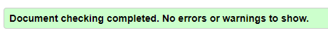

The code for my North Island page had no errors or warnings.

# **Sprint 4 (South Island Page)**

## **Scrum Board**

Before starting my fourth sprint I have moved all the items I need to add to the sprint backlog. The goal of this sprint is to complete the South Island page which includes attractions that are located within the South Island. This sprint is similar to sprint 3 when I made the north island page so it should be completed faster than the third sprint.

This is the first version of the scrum board

**2/09/2024**

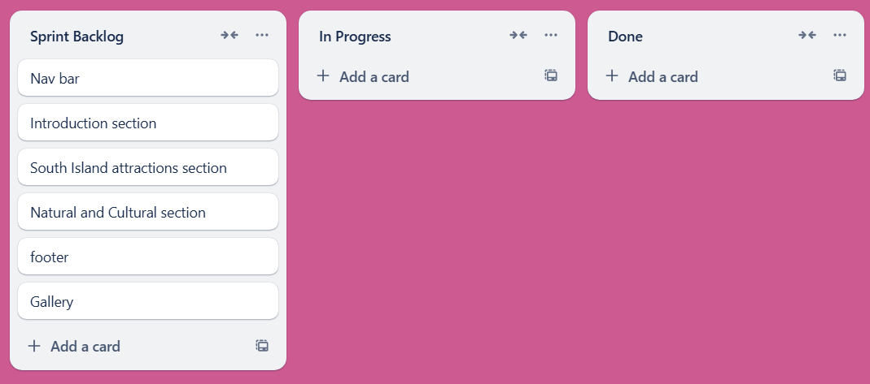

**3/09/2024**

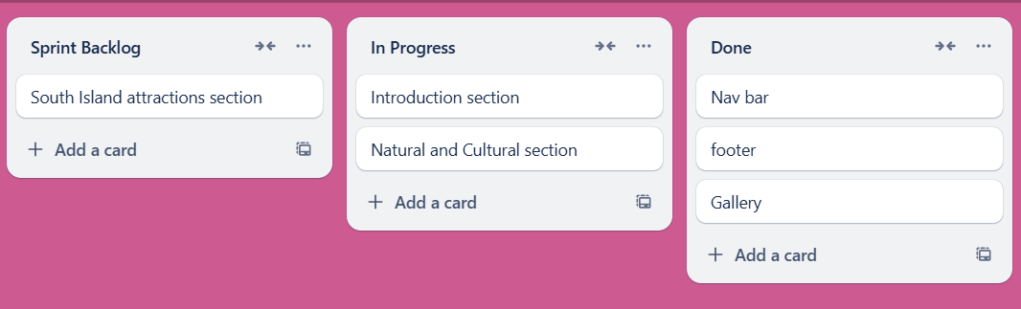

This is the scrum board as of 4/09/2024 I have completed the navigation bar, footer and the gallery, this is because I have reused these parts from the north island page. I am currently working on the natural and cultural section along with the introduction section of the website.

**4/09/2024**

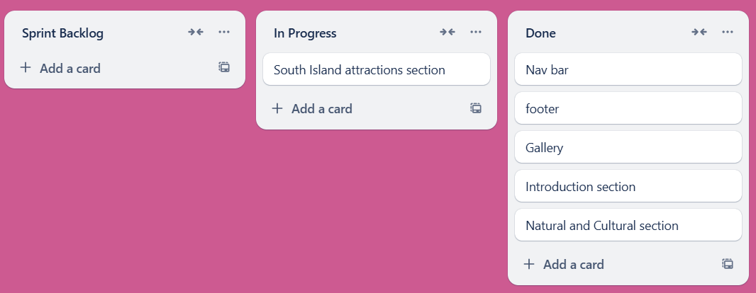

This is the scrum board as of 4/09/2024 I have completed the introduction section and the natural and cultural section. The last part that I need to complete is the attractions section which I have begun working on now. This means that there is nothing left in my sprint backlog that needs to be completed after the attractions section is done.

**7/09/2024**

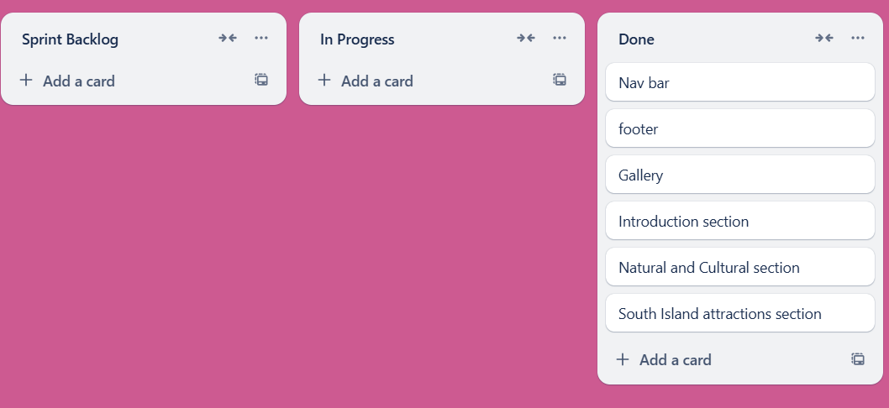

I have completed all the aspects of the South Island page

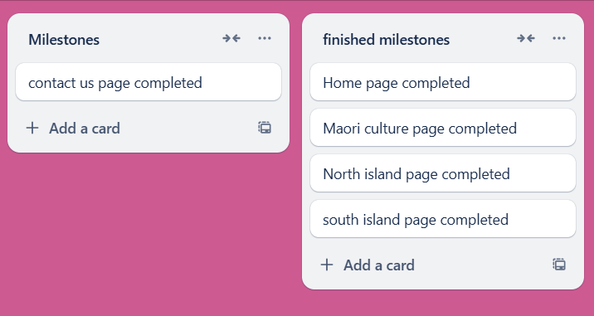

This means that I have completed another milestone.

## **Trialling**

|  |
| --- |
| **Component:**  Gallery image  **Trial 1:**  Milford Sound range reflected in water  Description automatically generated  Image option 1  **Trial 2:**    Image option 2  **Decision:**  I will be using image option 2 because people liked the way it contrasted the light colour of the website |

|  |
| --- |
| **Component:**  Card Image  **Trial 1:**    Padding between image and card border, image has full border rounding  **Trial 2:**    Padding between image and card border, top of image has rounding but no rounding on the bottom  **Trial 3:**    No padding between image and card border, top of image has rounding but bottom does not.  **Decision:**  I along with two other users came to the decision that trial 3 was more visually appealing than the previous ones this means it will be the layout I will be using. |

|  |
| --- |
| **Component:**  Box shadow  **Trial 1:**    No transparency  **Trial 2:**    Transparent light  **Trial 3:**    Darker shadow transparent  **Decision:**  Trial 3 was the most popular because it had a darker shadow that was not completely solid like. The reason I did not select trial 1 is because the shadow was too solid and the reason I did not select trial 2 was because the shadow was too light. |
| **Component:**  Card background  **Trial 1:**    Card background same as main background #fff  **Trial 2:**    #f5f5f5 using a slight grey to separate the cards from the background more  **Decision:**  I have decided to use the slight grey background because it helps differentiate the cards from the background. |

## **User and Client Feedback**

I gave my South Island page to users and my client to gather feedback. From this I gathered three improvements that can be made and have placed them in bullet points.

* Reduce opacity of text shadow (too sharp)
* Remove border rounding on image bottom
* Card background different colour to main background

1.

**Reduce opacity of text shadow**

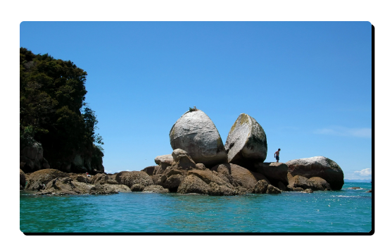

The text shadow is too sharp so I will make it less sharp by adding some transparency and making it a little bit lighter.

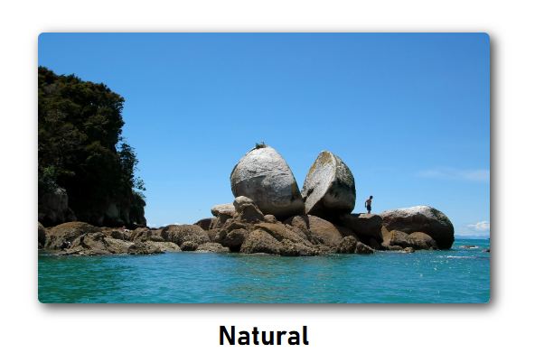

I have made the box shadow less sharp, and this is the version that was the most popular in the trialling.

2.

**Remove border rounding on image bottom**

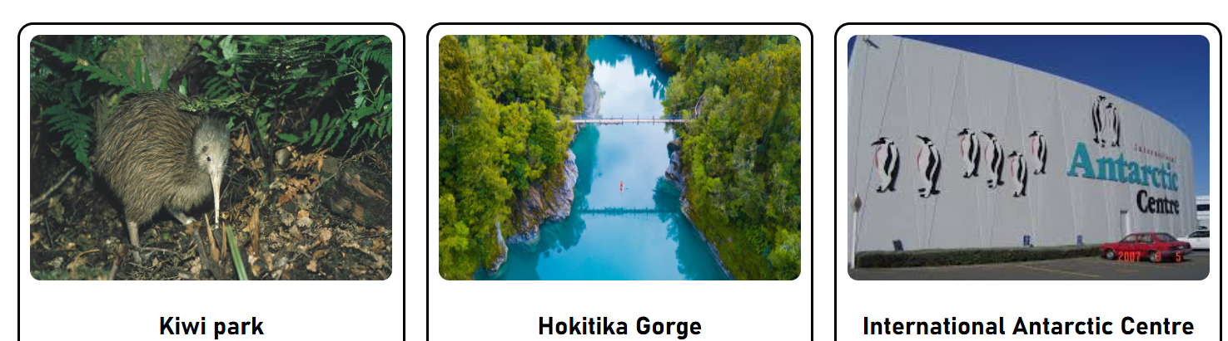

The rounded bottom has been changed to a flat bottom this is because the padding between the image and the border has been removed so the flat bottom helps to make the image fit better.

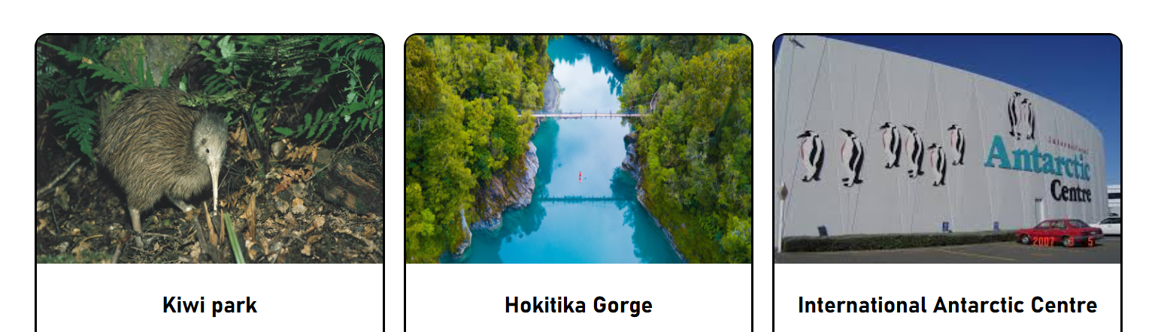

3.

**Card background different colour to main background**

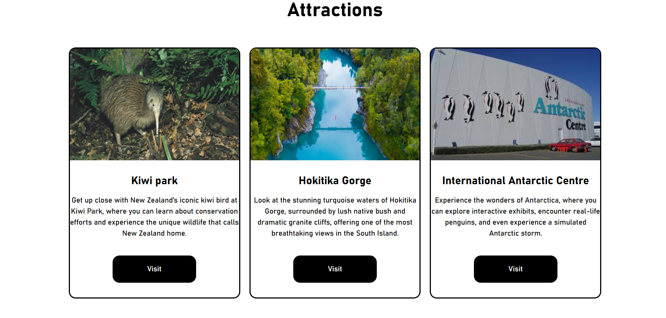

Currently the card background is the same as the main website background. I received feedback that making the background of the cards slightly different would make it look better.

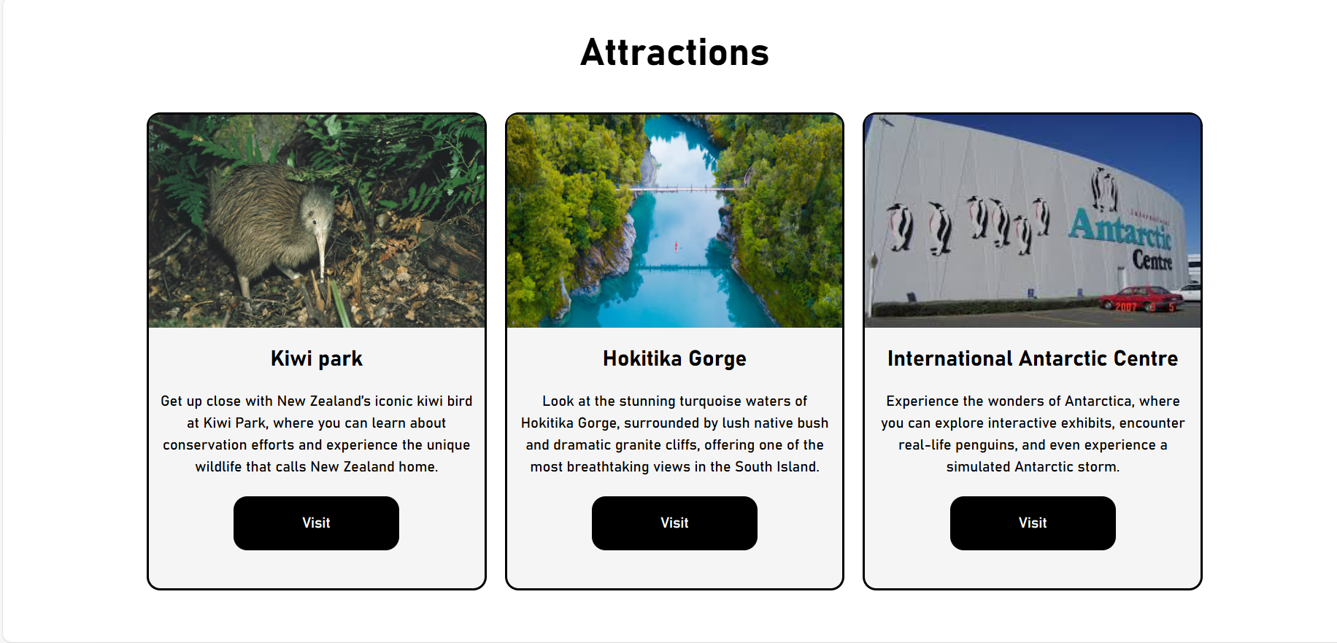

Here I made the card background a slight grey.

## **Testing**

|  |  |  |
| --- | --- | --- |
| **Number** | **Test** | **Evidence** *(screenshots, including before and after for iterative)* |
| **1** | All content must be readable | My website uses large font sizes which makes it easy for the user to read all the text on the website. |
| **2** | Navigation must work (No broken links) | All links on my website link to other pages successfully. I have checked every link including my logo and they all successfully link to the desired page. |
| **3** | Images displayed correctly, **optimised for the web**- alt | All images on my website have alt tags this means that if the image fails to load it will display a text telling the user what the image is. |
| 4 | No error in mark up or CSS (Validator evidence) | Originally my code had 1 error, but I fixed it and now there are no errors in my html. |
| 5 | Browser testing | I tested my website using Google Chrome and Microsoft Edge and it worked on both browsers. |
| 6 | All pages of your site are understandable and easy to use | I have applied the user and client feedback that I received on my website. |
| 7 | There is an access to the Main menu from all pages | There is a navigation bar that allows the user to access the home page and if the user clicks on the logo in the top left or in the footer then it will also return the user to the home page |
| 8 | There are no grammar and spelling mistakes. The data is typed correctly without errors | I have checked all my spelling and there are no spelling or grammar errors present. |
| 9 | Images are placed properly with proper size (No stretching etc) | The images on my website are placed correctly where they are intended to be, and they display without stretching. |
| **10** | Content should be informative, understandable, structured and logically linked | All the elements on my website are structured and understandable. |
| **11** | Evidence of design elements: layout, colours, fonts, font sizes, labels, text boxes, text formatting, captions, buttons, lists, icons, links | This website uses large font sizes to make all the content easily readable for everyone, I am using the font Bahnshrift as that was the font that was decided on in my font research during the conceptual it also is consistent with the other page from sprint one, two and three. The text in my website is centred. My website has buttons and links in the nav bar, it does not have any lists. My website generally uses a black and white colour scheme however the images do provide colour to the website. |
| **12** | Code commenting is helpful | I have code comments included in my code with each section to show me which part of my website each section of code is connected to. |
| **13** | alt text for all images and it matches the image | All images in my code have their own alt text attached. |
| **14** | All information included | All information is included in the South Island page. |
| **15** | All pages have a consistent look and feel | I have created 4 pages so far these are the home page, Māori culture page, North Island page, and the South Island page. they have a consistent look and feel as they are both created using the wireframes / high fidelity that I made in my conceptual I also intend on making the final page consistent with the other completed pages. |
| **16** | All files saved in one folder (sub folders if needed) | Everything is saved in the same folder  And all the images that are used on the South Island page are saved in a relevant sub folder called “south-images” |
| **17** | Files and folders named correctly (no spaces, capitals, well named) | All files do not include spaces or capitals. The files all use names that relate to them. |

## **Code Validation**

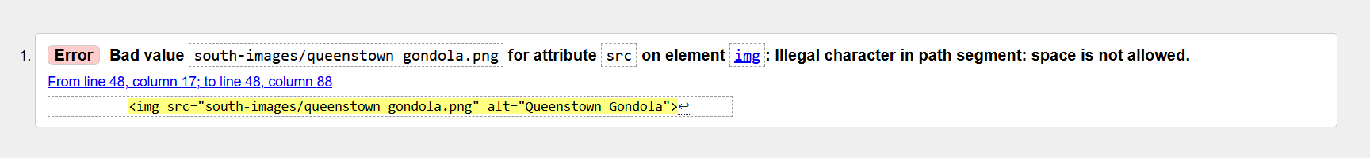

My code for the South Island page only had one error which was a space in a file path.

Before:



After:



I have fixed this error by adding a hyphen between the two words in the file path.



This means that I have no more style errors in my code for this page.

# **Sprint 5 (Contact Us Page)**

## **Scrum Board**

This is my 5th sprint which is the final planned sprint in the development of my website. The page that I will be developing is the contact us page which will be the smallest page on the website. The goal of this sprint is to finish this page and thus complete every page for my website.

This is the first version of my scrum board.

**8/09/2024**

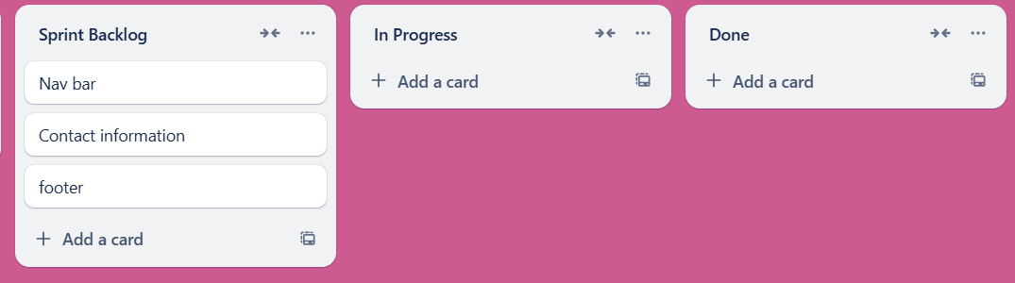

**9/09/2024**

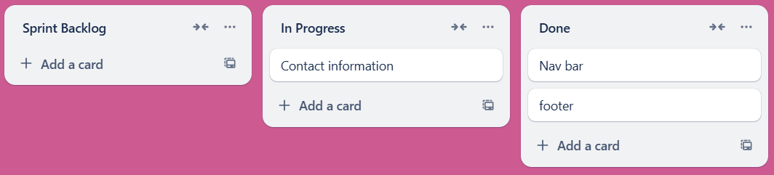

This is my scrum board as of 9/09/2024 I have completed the navigation bar and the footer for my website, and I have begun working on the contact information for the contact us page.

**11/09/2024**

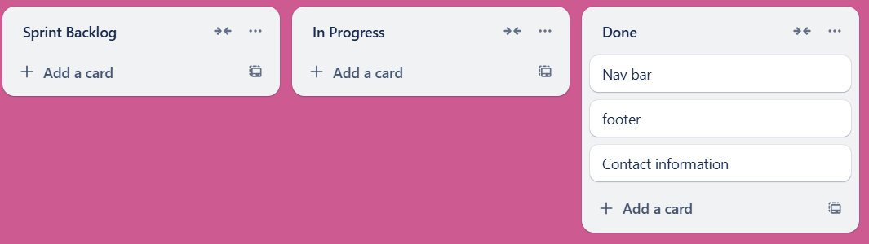

This is my scrum board as of 11/09/2024, I have completed all the aspects of my website that and everything that is in my sprint backlog.

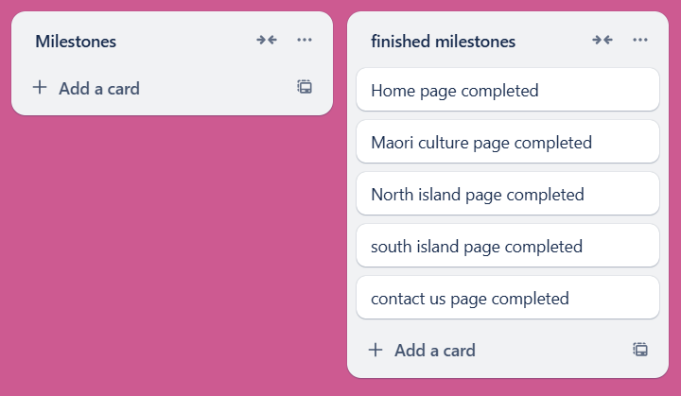

This means I have now completed all the milestones for the development of my website as this was my last milestone.

## **Trialling**

|  |
| --- |
| **Component:**  Submit form button  **Trial 1:**    Black submit form button (becomes red on hover)  **Trial 2:**    Red submit form (becomes black on hover)  **Decision:**  I will be using Trial 1 where the submit button is black and becomes red when the user hovers over it. This is because the black colour fits with the rest of the form and it becomes more noticeable for the user when it becomes red on hover. |
| **Component:**  Contact form size  **Trial 1:**    Thin contact form  **Trial 2:**    Wider contact form  **Decision:**  The wider contact form was more popular because the page felt less empty. |

## **User and Client Feedback**

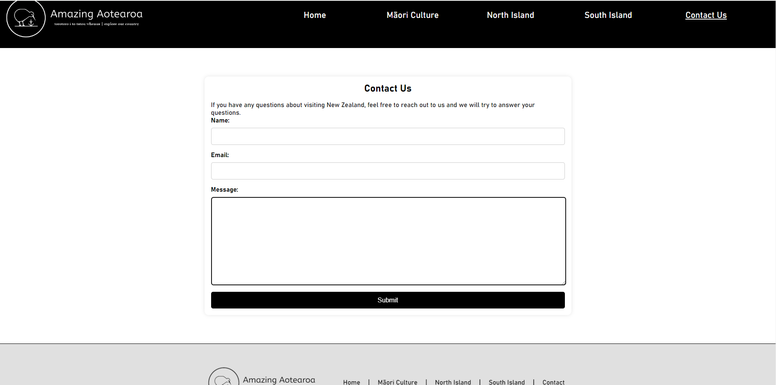

This was my contact us page when I gave it to my client and users for feedback.

I received feedback that the page felt too empty because there was not much content on the page. To address this, I am going to add an extra section to the page. To figure out what I could add I discussed with my client about what options there are, and we decided that the best option is to add a FAQ (frequently asked questions) section underneath the contact form, this would have the benefit of reducing the number of people who need to contact us because they will get the answers to their most commonly asked questions.

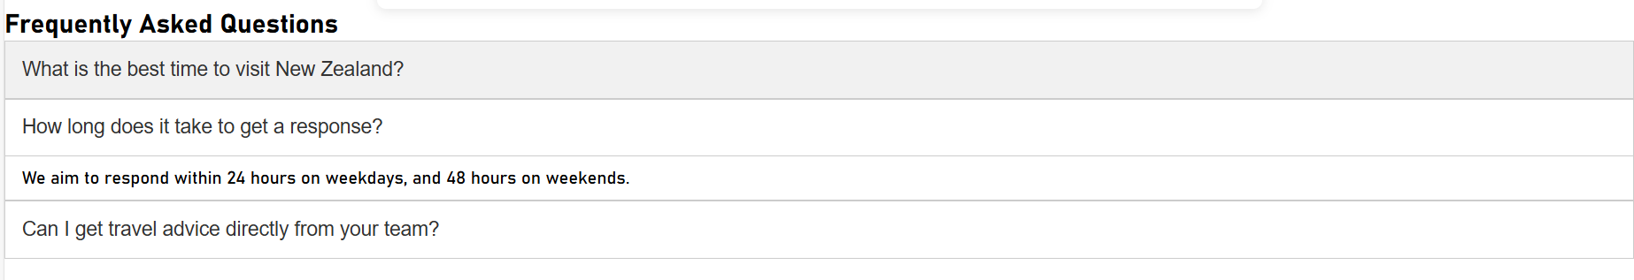

I have added a frequently asked questions section to my website with three questions and answers, the questions are in a box that will drop down and show the answer to the question when clicked and it will darken when the user hovers over the button.

After showing my frequently asked questions section to users I received feedback that I should add an arrow to the button that shows whether the box is expanded or not. I also received feedback that the layout for the frequently asked questions did not look good, and they wanted me to centre it and make it look better.

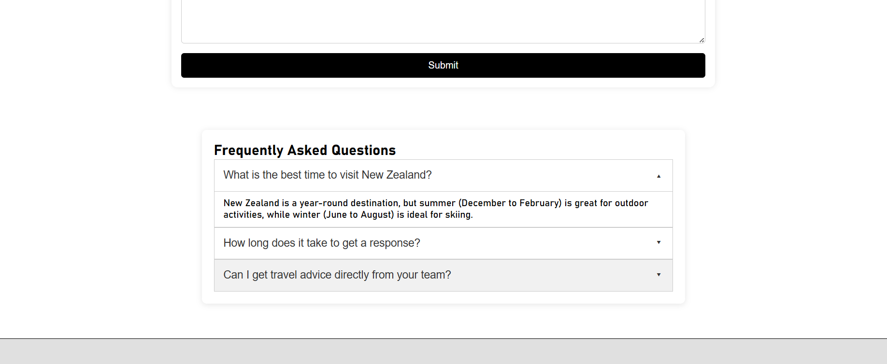

This is the frequently asked questions after I applied the feedback, I have centred them and made it look better. I have also added arrows to show if the box is expanded or not.

## **Testing**

|  |  |  |
| --- | --- | --- |
| **Number** | **Test** | **Evidence** *(screenshots, including before and after for iterative)* |
| **1** | All content must be readable | All the content on this page is easy to read. |
| **2** | Navigation must work (No broken links) | I have tested every link on the contact us page to ensure that every link works and takes the user to the desired page. |
| **3** | Images displayed correctly, **optimised for the web**- alt | There are no images used on this page. |
| 4 | No error in mark up or CSS (Validator evidence) |  |
| 5 | Browser testing | I tested the website in Google Chrome and Microsoft Edge and made sure that it works on both browsers. |
| 6 | All pages of your site are understandable and easy to use | I received feedback for my website from users and my client which I have applied to the page. |
| 7 | There is an access to the Main menu from all pages | There is a navigation bar that allows the user to access the home page and if the user clicks on the logo in the top left or in the footer then it will also return the user to the home page. |
| 8 | There are no grammar and spelling mistakes. The data is typed correctly without errors | I have checked all my spelling and there are no spelling or grammar errors present. |
| 9 | Images are placed properly with proper size (No stretching etc) | There are no images on this page |
| **10** | Content should be informative, understandable, structured and logically linked | All the elements on my website are understandable and easy to understand, they all serve their purpose and are logically linked to the topic of the page. |
| **11** | Evidence of design elements: layout, colours, fonts, font sizes, labels, text boxes, text formatting, captions, buttons, lists, icons, links |  |
| **12** | Code commenting is helpful | I have code comment for each section of the website to make it easy to find where each part of the website is in the code. |
| **13** | alt text for all images and it matches the image | There are no images on this page |
| **14** | All information included | All information is included on the contact page. |
| **15** | All pages have a consistent look and feel | This page remains consistent with the other 4 pages of the website. It uses the same colour scheme, but it does differ slightly as it is used for contacting us instead of providing content for the website. |
| **16** | All files saved in one folder (sub folders if needed) | All files are saved in the same folder. |
| **17** | Files and folders named correctly (no spaces, capitals, well named) | The file is called “contact.html” which includes no spaces or capitals and is named appropriately for the page. |

## **Code Validation**



The code for my contact us page had no errors or warnings.

# **CSS Code Validation**

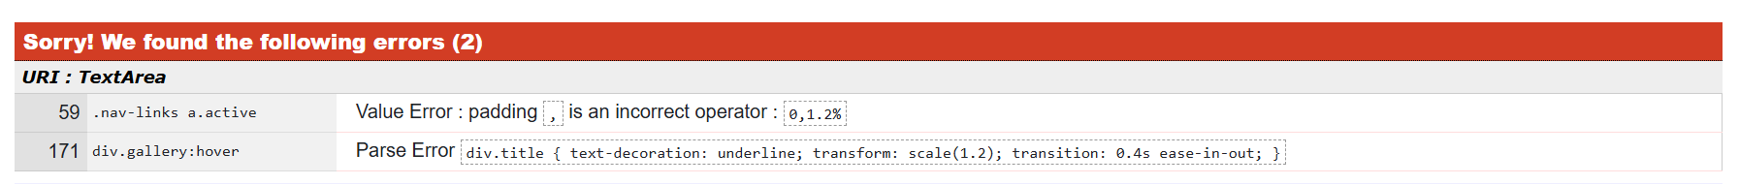

These are the errors that were found in my CSS code.

1.



This is the first error it is caused by the use of a “,” when it should not be used.

Code before:



Code after:





2.



This is the second error it is caused by a parse error

Code before:

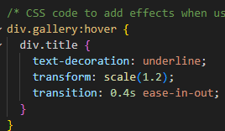

Code after:

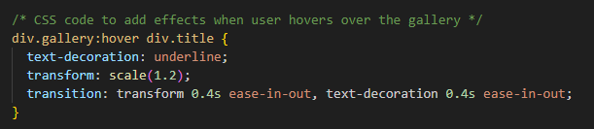



All CSS errors have been fixed.

# **Relevant Implications**

**Cultural:**

New Zealand is a diverse and multi-cultural country this means that our website should reflect that as the website is about tourism in New Zealand. Māori are a large part of New Zealand culture, so it is important they are represented on the website. To do this Māori tourist locations will be included on our website under the North and South Island pages. Māori cultural tourism locations will also have their own dedicated page for people who are interested in exploring Māori culture in New Zealand. Our goal is to display these attractions such as the Waitangi treaty grounds in a respectful and informative manner on our website. By doing this we include Māori culture into the website and acknowledge its importance to New Zealand culture.

## **End User Considerations**

**Functionality:**

It is important that the website is functional for the end user. This means that the website should have good performance so it must be able to run effectively and smoothly and avoid long loading times. If the functionality of the website is slow, then the end users experience will be affected and may cause them to leave and go somewhere else. One way of improving the websites functionality is using images with lower resolution or dimensions this will speed up the loading times as images often take the longest to load due to being larger file sizes than HTML and CSS, but it is important that the image remains high quality. The website should also be compatible and functional on different devices such as computers and mobile devices. This has been accounted for in the wireframes by designing a layout for mobile devices. Smaller screen sizes can be accounted for in the websites code by scaling features and images.

**Usability:**

It is important that the website can be used effectively by the end user to do this there are multiple considerations that must be made. These include keeping the website consistent, so the user knows what is going on, giving the user the ability to navigate easily through the website, using symbols that the user understands the meaning of and preventing accidental errors from occurring as well as helping them to fix errors that do occur. Usability is important because it impacts the way the user can use the website and has a large impact on the user experience.

**Aesthetics:**

It is important that the website looks visually appealing to the end user this is done through the colours, images, text, and layout that is used on the website. Aesthetics is important because it affects the way the end user sees the website if the website is cluttered and overcrowded with items then the user may feel overwhelmed and not know what to do. By keeping the websites design consistent with itself it makes the website feel more connected and professional this is done by using the same colour scheme and font across all pages along with that keeping the pages layouts similar it helps the website feel more consistent. To improve the aesthetics and consistency of the website I did font and colour research for the website and used user feedback along with my client’s feedback to find colours and a font that the users and client both liked. I also placed these along with other elements into design tiles to see how they worked together and make sure they would work on a website.

**Accessibility:**

It is important that the website is accessible to all users who use it. Accessibility is important because without it some users would be unable to use the website, and the user experience would be affected for them. The accessibility of a website can be improved through design that adapts and scales to fit the users screen size ensuring they still receive the optimal user experience. The accessibility can also be improved by using fonts that are easy to read ensuring everyone can read the text easily. Adding an alt text to images also helps improve the accessibility of the website by showing a description of an image if the image fails to load.

## **Legal**

**Intellectual Property:**It is important that the website complies with the laws in New Zealand about intellectual property. If my website does not follow these laws and infringes any of these laws, it could result in legal action being taken against the website that I create. Intellectual property is defined by the World Intellectual Property Organization as “creations of the mind, such as inventions; literary and artistic works; designs; symbols, names and images used in commerce” Intellectual property laws protect these creations through copyright, trademark, and patents. Copyright in New Zealand follows the copyright act of 1994 which protects all original works of text, images, videos, and software code when it is created. The person who creates the work that is protected is usually the person who owns the rights to that work unless it is created under a contract or employment agreement. If copyrighted works are used on the website, it will allow the copyright holder to request it removal or take legal action. This means that my website cannot use works if it is protected by copyright unless I have permission to use it or if it counts as fair use. Trademark protects properties that can be used to identify a brand such as their logo or brand name. In New Zealand trademarks are registered by the Intellectual Property Office of New Zealand under the trademarks act 2002. It is important for my website not to use any registered trademark because it can create legal problems. The final type of intellectual property is patents which are used to protect new and unique creations, patents are given by the Intellectual Property Office of New Zealand from the patent act of 2013. Patents give a creator the exclusive rights to use and sell their creation. This means that my website cannot use creations that have been patented unless I get permission from the patent holder.

Relevant intellectual property symbols:

Copyright:

©

Used to show that you own the copyright to this work.

Trademark

Unregistered / pending trademarks:

TM

Used to show that you are considering or have applied for a trademark.

Unregistered / pending service marks:

SM

Used to protect the services that your business provides.

Registered trademarks:

®

Used to show that your trademark has been officially registered.

Creative Commons:



Allows other people to use a copyrighted work if they follow the owners’ terms such as giving the owner credit.

**Privacy:**

It is important that the website does not violate any user’s privacy or the privacy of anyone included on the website. It is important that if the website collects data, it does not collect data that is too intrusive, and it makes sure that the data is saved securely. If images are used on the website that include people that can be identified, then the website must have consent from that person for their photo to be used. My website will be using images that do not include people in them so this is will not be a problem however if I choose to use an image that includes people in it then I will need to receive their permission. My website will not be collecting cookies which are small pieces of text that your browser uses to help remember information and collect data from the users visit. This Is because the website that I am making for my client does not have any form of account login or data that needs to be remembered, my website will also not be collecting data. Because the website is also not collecting data it means that I will not need to worry about where the data is stored, however if I did collect data, I would need to make sure the data is saved securely this can be done through encryption which will prevent the data from being stolen.

# **Evaluation**

## **Planning:**

The first step in creating the website was plan the development. To do this I first needed to choose a method of development. The options that I picked from included the waterfall method or the scrum method. I compared the two options and eventually I decided to use the scrum method instead of the waterfall method this is because it would allow me to iterate on the development and apply feedback easier than the waterfall method which does not allow for iterations as easily so by picking the scrum method it would allow me to make my website higher quality.



This was the first step in my planning because I now knew what method I was going to use to make the website, but I now needed to plan the things I would need to work on, and I needed to plan how I would use my time. To plan the things, I needed to work on I looked at decomposition tools that I could use to split the process into smaller tasks that were easier to manage. I looked at three decomposition tools these were a decomposition table, to do list, and a mind map. From these three options I decided to use two of them which were the decomposition table and a to do list. The reason that I chose to use a to do list was because it is a simple way to see a list of things that need to be done. I also chose to use a decomposition table because it allows me to see all aspects and I could separate it into sprints which means that it works well with the scrum method. This allows me to split the task into smaller tasks that are easier to manage and allow me to focus on one thing at a time.

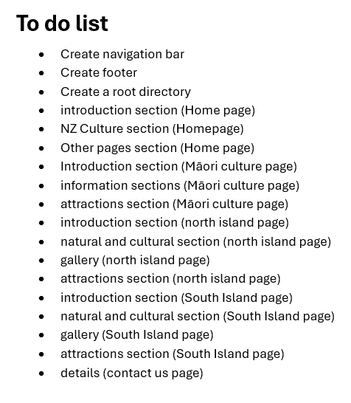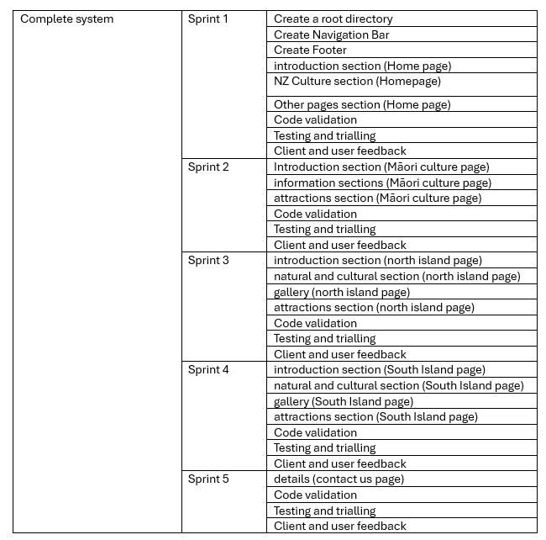

Next, I compared tools that I would use to plan and manage my project, I compared three tools these were a calendar, Gantt chart and a scrum board. I decided to use a Gantt chart and a scrum board for my project. I decided to use a scrum board because it would allow me to track each sprint that I use and my progress through them and I decided to use a Gantt chart so that I could track my progress through the whole project and make sure that I was still on schedule.



I would iterate on these tools as I progressed. Using these two tools helped to keep me on track and make sure that I finished my project on time.

## **Testing:**

After each sprint I did testing on the page I had created to make sure it met all the requirements it needed to meet to ensure that the page was high quality. If something did not meet the requirements of the testing, then I would improve it so that it did meet the requirements of the testing and then I would show the proof that it meets the requirements. All testing was done for each sprint under the heading called “testing”. Along with testing I would also validate the code that I had written to make sure it met coding conventions. If my code included errors that did not meet the coding conventions, I would fix the code so that it did not have any errors, this was done for each sprint under the heading called “code validation”

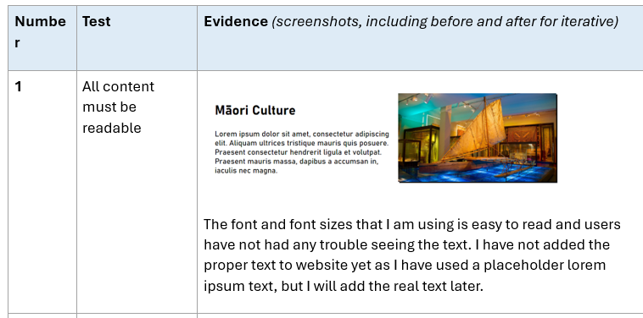

## **Trialling:**

As I worked on the website, I would trial some different things to see which version people preferred. Some examples of things I trialled include the corner rounding on buttons, box shadows and images used. Using the options I would pick the option that people preferred and that would be the version that I implemented and kept on my website. This allowed my final outcome to be higher quality because I was able to find better options compared to the originally intended version of something. My trialling usually led to me using something different from what was originally intended because people preferred the way the other option looked. The trialling that I did for each sprint was included under the heading called “trialling”.

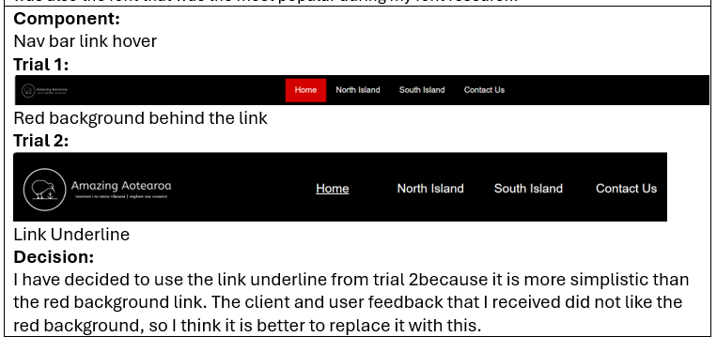

## **Overall reflection:**

# **Future improvements**

# **Home Page HTML Code**

<!DOCTYPE html>

<html lang="en">

    <head>

        <!-- CSS -->

        <link rel="stylesheet" href="style.css">

        <!-- script -->

        <script src="script.js"></script>

        <title>Amazing Aotearoa Home Page</title>

    </head>

    <body>

        <!-- Navigation bar-->

        <div class="topnav">

            <a href="home.html">

                <img src="website-logo-inverted-transparent.png" alt="Logo" class="logo">

            </a>

            <div class="nav-links">

                <a class="active" href="home.html">Home</a>

                <a href="maori.html">Māori Culture</a>

                <a href="north.html">North Island</a>

                <a href="south.html">South Island</a>

                <a href="contact.html">Contact Us</a>

            </div>

        </div>

        <br>

        <!-- hero section -->

        <section>

        <div class="hero">

            <div class="hero-text">

                <h1>Torotoro i to tatou whenua</h1>

                <h2>Explore our country</h2>

                <p>Welcome to New Zealand, A beautiful country with breathtaking natural landscapes, a unique and diverse culture and, plenty of things you can do</p>

                <button onclick="location.href='#section2'" >Discover New Zealand</button>

            </div>

            <img src="home-images/milford-sound.png" alt="Milford Sound" class="hero-image">

        </div>

        </section>

        <br>

        <hr>

        <br>

        <!-- culture section -->

        <section>

        <div class="culture">

            <div class="culture-text">

                <h1>New Zealand Culture</h1>

                <p>Discover New Zealand’s rich and diverse culture that has been made up from a mix of many different people’s cultures along with the indigenous Māori people of New Zealand. New Zealand is a multicultural society that consists of all sorts of various and unique cultures and people from all over the world.</p>

            </div>

            <img src="home-images/culture-homeS.png" alt="Waitangi Treaty Grounds" class="culture-image">

        </div>

        </section>

        <!-- black background section -->

        <div class="black-background reveal" id="section2">

            <div class="responsive">

                <div class="gallery">

                  <div class="title">Māori Culture</div>

                  <div class="gallery-container">

                    <a target="_self" href="maori.html">

                      <img src="home-images/home-marae.png" alt="Marae" width="600" height="400">

                    </a>

                  </div>

                  <div class="desc">Māori Culture is an important part of New Zealand’s identity, Māori culture has its own mythology, history and traditions. </div>

                </div>

              </div>

              <div class="responsive">

                <div class="gallery">

                  <div class="title">North Island</div>

                  <div class="gallery-container">

                    <a target="_self" href="north.html">

                      <img src="home-images/home-auckland.png" alt="Auckland" width="600" height="400">

                    </a>

                  </div>

                  <div class="desc">The North Island also known as Te Ika-a-Maui is home to Wellington the capital city of New Zealand and Auckland the largest city in New Zealand. But it also offers many other things to do and see.</div>

                </div>

              </div>

              <div class="responsive">

                <div class="gallery">

                  <div class="title">South Island</div>

                  <div class="gallery-container">

                    <a target="_self" href="south.html">

                      <img src="home-images/home-queenstown.png" alt="Queenstown" width="600" height="400">

                    </a>

                  </div>

                  <div class="desc">The South Island also known as Te Waipounamu is the largest island in New Zealand it holds the southern alps and Mount Cook the tallest mountain in New Zealand. You can visit the amazing fjords in Milford Sound or even enjoy everything there is to do in Queenstown along with much more.   </div>

                </div>

              </div>

              <div class="clearfix"></div>

            </div>

        <br>

        <!-- footer -->

        <footer class="footer">

          <div class="footer-logo">

            <a href="home.html">

              <img src="website-logo-transparent.png" alt="Logo">

            </a>

          </div>

          <div class="footer-nav">

              <a href="home.html">Home</a> |

              <a href="maori.html">Māori Culture</a> |

              <a href="north.html">North Island</a> |

              <a href="south.html">South Island</a> |

              <a href="contact.html">Contact</a>

          </div>

          <div class="footer-copyright">

              &copy; 2024 Amazing Aotearoa. All rights reserved

          </div>

      </footer>

    </body>

</html>

# **Māori Culture Page HTML Code**

<!DOCTYPE html>

<html lang="en">

    <head>

        <!-- CSS -->

        <link rel="stylesheet" href="style.css">

        <!-- script -->

        <script src="script.js"></script>

        <title>Amazing Aotearoa Culture Page</title>

    </head>

    <body>

        <!-- Navigation bar-->

        <div class="topnav">

            <a href="home.html">

                <img src="website-logo-inverted-transparent.png" alt="Logo" class="logo">

            </a>

            <div class="nav-links">

                <a href="home.html">Home</a>

                <a class="active" href="maori.html">Māori Culture</a>

                <a href="north.html">North Island</a>

                <a href="south.html">South Island</a>

                <a href="contact.html">Contact Us</a>

            </div>

        </div>

        <br>

        <br>

        <!-- hero section -->

        <section>

            <div class="hero">

                <div class="hero-text">

                    <h1>Māori Culture</h1>

                    <p>Māori culture is deeply rooted in the traditions, beliefs, and practices of the indigenous people of New Zealand. Known for their distinctive art forms, such as wood carvings, tattoos (moko), and weaving, the Māori express their rich history and spiritual connection to the land. This page will showcase wonderful attractions that display the Māori culture</p>

                </div>

                <img src="maori-images/maori-carving.png" alt="Māori carving" class="hero-image">

            </div>

        </section>

        <!-- black background section -->

        <div class="black-background reveal">

            <div class="responsive">

                <div class="gallery">

                  <div class="title">Buried Village of Te Wairoa</div>

                  <div class="gallery-container">

                    <a target="_self" href="#">

                      <img src="maori-images/maori-village.png" alt="Māori Village" width="600" height="400">

                    </a>

                  </div>

                  <div class="desc">The Buried Village of Te Wairoa is an archaeological site near Rotorua, New Zealand, famously buried under volcanic ash from the 1886 eruption of Mount Tarawera.</div>

                </div>

              </div>

              <div class="responsive">

                <div class="gallery">

                  <div class="title">Tane Mahuta</div>

                  <div class="gallery-container">

                    <a target="_self" href="#">

                      <img src="maori-images/tane-mahuta-attraction.png" alt="Tane Mahuta" width="600" height="400">

                    </a>

                  </div>

                  <div class="desc">Tane Mahuta, the tallest known tree in New Zealand, stands majestically in the Waipoua Forest. This ancient kauri tree reaches a height of 51.2 meters (168 feet) and is estimated to be between 1,250 and 2,500 years old. Named after the Māori god of the forest, Tane Mahuta is a living testament to the grandeur of New Zealand’s natural heritage. </div>

                </div>

              </div>

              <div class="responsive">

                <div class="gallery">

                  <div class="title">Tamaki Māori Village</div>

                  <div class="gallery-container">

                    <a target="_self" href="#">

                      <img src="maori-images/maori-building.png" alt="Māori building" width="600" height="400">

                    </a>

                  </div>

                  <div class="desc">Tamaki Māori Village offers an immersive experience into Māori culture and traditions. Located in Rotorua, the village provides visitors with a unique opportunity to participate in authentic Māori ceremonies, enjoy traditional feasts, and witness performances of the haka and songs. The village recreates a historical Māori village setting.</div>

                </div>

              </div>

              <div class="clearfix"></div>

            </div>

        <br>

        <!-- this section is for the part that talks about Maori culture-->

        <section>

            <div class="section">

                <div class="section-text">

                    <h1>Māori Culture</h1>

                    <p>The waka, or traditional Māori canoe, is a powerful symbol of Māori culture and heritage. These canoes were pivotal in their journeys across the Pacific Ocean that brought the Māori people to New Zealand. Often adorned with intricate carvings, waka were essential for navigation and transport. They represent the Māori’s profound connection to the sea.</p>

                </div>

                <img src="maori-images/maori-waka.png" alt="Milford Sound" class="hero-image">

            </div>

        </section>

        <hr>

        <br>

<!-- This section is for the cards that display the attractions-->

        <section class="attractions">

          <h2>Attractions</h2>

          <br>

          <div class="attractions-container">

              <div class="attractions-slide">

                  <div class="card">

                      <img src="maori-images/te-ana-maori-rock-art.png" alt="Te Ana Maori rock art centre">

                      <h3>Te Ana Māori rock art centre</h3>

                      <p>showcases the rich heritage of Māori rock art through interactive exhibits and preserved artworks, offering a glimpse into the ancient artistic traditions of New Zealand's indigenous people.</p>

                      <a href="#" class="btn">Visit</a>

                  </div>

                  <div class="card">

                      <img src="maori-images/marae-card.png" alt="Marae">

                      <h3>Waitangi Treaty Grounds</h3>

                      <p>Is the historic site where the Treaty of Waitangi was signed in 1840, marking a foundational moment in New Zealand’s history and symbolizing the partnership between the Māori people and the British Crown.</p>

                      <a href="#" class="btn">Visit</a>

                  </div>

                  <div class="card">

                      <img src="maori-images/tane-mahuta-attraction.png" alt="Tane Mahuta">

                      <h3>Tane Mahuta</h3>

                      <p>is the tallest known kauri tree in New Zealand, standing at 51.2 meters and estimated to be between 1,250 and 2,500 years old, embodying the majesty and longevity of the ancient forests of New Zealand.</p>

                      <a href="#" class="btn">Visit</a>

                  </div>

              </div>

          </div>

        </section>

          <br>

          <br>

          <br>

          <br>

          <br>

                <!-- footer -->

                <footer class="footer">

                  <div class="footer-logo">

                    <a href="home.html">

                      <img src="website-logo-transparent.png" alt="Logo">

                    </a>

                  </div>

                  <div class="footer-nav">

                      <a href="home.html">Home</a> |

                      <a href="maori.html">Māori Culture</a> |

                      <a href="north.html">North Island</a> |

                      <a href="south.html">South Island</a> |

                      <a href="contact.html">Contact</a>

                  </div>

                  <div class="footer-copyright">

                      &copy; 2024 Amazing Aotearoa. All rights reserved

                  </div>

              </footer>

        </body>

</html>

# **North Island Page HTML Code**

<!DOCTYPE html>

<html lang="en">

    <head>

        <!-- CSS -->

        <link rel="stylesheet" href="style.css">

        <!-- script -->

        <script src="script.js"></script>

        <title>Amazing Aotearoa North Island Page</title>

    </head>

    <body>

        <!-- Navigation bar-->

        <div class="topnav">

            <a href="home.html">

                <img src="website-logo-inverted-transparent.png" alt="Logo" class="logo">

            </a>

            <div class="nav-links">

                <a href="home.html">Home</a>

                <a href="maori.html">Māori Culture</a>

                <a class="active" href="north.html">North Island</a>

                <a href="south.html">South Island</a>

                <a href="contact.html">Contact Us</a>

            </div>

        </div>

        <!-- Introduction section with a hero image and text -->

        <section>

            <div class="hero">

                <div class="hero-text">

                    <h1>North Island</h1>

                    <p>Explore the vibrant diversity of New Zealand's North Island, known for its stunning landscapes, from volcanic peaks and lush forests to bustling cities and serene beaches. The island is rich in both natural beauty and cultural experiences, offering something for every traveler.</p>

                </div>

            </div>

        </section>

        <br>

        <br>

        <!-- Introductory content about North Island -->

        <div class="intro-row">

            <!-- Natural attractions card -->

            <div class="intro-card">

                <img src="north-images/cape-reinga.png" alt="Cape Reinga">

                <h3>Natural</h3>

                <p>Discover the breathtaking natural wonders of the North Island from the stunning coastal scenery of Cape Reinga to the geothermal marvels of Rotorua.</p>

            </div>

            <!-- Cultural attractions card -->

            <div class="intro-card">

                <img src="north-images/skytower-auckland.png" alt="Skytower">

                <h3>Cultural</h3>

                <p>The North Island is a cultural hub, home to significant Maori heritage sites and dynamic urban centers. Experience the rich history and vibrant arts scene.</p>

            </div>

        </div>

        <div class="intro-row">

            <!-- Additional natural attractions card -->

            <div class="intro-card">

                <img src="north-images/waitomo-caves.png" alt="waitomo-caves">

                <h3>Natural</h3>

                <p>The island's landscapes are as diverse as they are beautiful.</p>

            </div>

            <!-- Additional cultural attractions card -->

            <div class="intro-card">

                <img src="north-images/auckland-war-memorial-museum.png" alt="Auckland war memorial museum">

                <h3>Cultural</h3>

                <p> Discover many things such as the sacred Waitangi Treaty Grounds to the contemporary museums and galleries of Wellington and Auckland.<p>

            </div>

        </div>

        <br>

        <!-- Parallax scrolling section with a link to the gallery -->

        <div class="parallaxN">

            <a href="home.html" class="gallery-button"> Gallery</a>

        </div>

        <br>

        <br>

        <!-- Attractions section -->

        <section class="attractions">

            <h2>Attractions</h2>

            <br>

            <br>

            <div class="attractions-container">

                <div class="attractions-slide">

                    <!-- Hobbiton attraction card -->

                    <div class="card">

                        <img src="north-images/hobbiton.png" alt="Hobbtion">

                        <h3>Hobbiton</h3>

                        <p>Step into the magical world of Middle-earth with a visit to Hobbiton, where the iconic film set from 'The Lord of the Rings' and 'The Hobbit' comes to life.</p>

                        <a href="#" class="btn">Visit</a>

                    </div>

                    <!-- Skytower attraction card -->

                    <div class="card">

                        <img src="north-images/skytower-auckland.png" alt="Skytower">

                        <h3>Skytower</h3>

                        <p>Experience breathtaking panoramic views of Auckland city's stunning skyline from inside the SkyTower, the tallest building in all of New Zealand.</p>

                        <a href="#" class="btn">Visit</a>

                    </div>

                    <!-- Te Puia attraction card -->

                    <div class="card">

                        <img src="north-images/te-puia.png" alt="Te Puia">

                        <h3>Te Puia</h3>

                        <p>Explore the geothermal wonders and rich Maori culture at Te Puia in Rotorua, where you can witness geysers, mud pools, and traditional Maori carving.</p>

                        <a href="#" class="btn">Visit</a>

                    </div>

                </div>

            </div>

          </section>

          <br>

          <br>

          <br>

        <!-- footer -->

        <footer class="footer">

            <div class="footer-logo">

              <a href="home.html">

                <img src="website-logo-transparent.png" alt="Logo">

              </a>

            </div>

            <div class="footer-nav">

                <a href="home.html">Home</a> |

                <a href="maori.html">Māori Culture</a> |

                <a href="north.html">North Island</a> |

                <a href="south.html">South Island</a> |

                <a href="contact.html">Contact</a>

            </div>

            <div class="footer-copyright">

                &copy; 2024 Amazing Aotearoa. All rights reserved

            </div>

        </footer>

    </body>

</html>

# **South Island Page HTML Code**

<!DOCTYPE html>

<html lang="en">

    <head>

        <!-- CSS -->

        <link rel="stylesheet" href="style.css">

        <!-- script -->

        <script src="script.js"></script>

        <title>Amazing Aotearoa South Island Page</title>

    </head>

    <body>

        <!-- Navigation bar-->

        <div class="topnav">

            <a href="home.html">

                <img src="website-logo-inverted-transparent.png" alt="Logo" class="logo">

            </a>

            <div class="nav-links">

                <a href="home.html">Home</a>

                <a href="maori.html">Māori Culture</a>

                <a href="north.html">North Island</a>

                <a class="active" href="south.html">South Island</a>

                <a href="contact.html">Contact Us</a>

            </div>

        </div>

        <!-- Introduction section with a hero image and text -->

        <section>

            <div class="hero">

                <div class="hero-text">

                    <h1>South Island</h1>

                    <p>Discover the South Island, a land of dramatic landscapes and rich experiences, where towering mountains, pristine lakes, and vibrant cities come together to offer endless opportunities for adventure, relaxation, and exploration.</p>

                </div>

            </div>

        </section>

        <br>

        <br>

        <!-- Introductory content about North Island -->

        <div class="intro-row">

            <!-- Natural attractions card -->

            <div class="intro-card">

                <img src="south-images/abel-tasman-park.png" alt="Abel Tasman National Park">

                <h3>Natural</h3>

                <p>Explore the stunning natural landscapes, from coastal wonders to majestic mountain ranges, offering diverse and breathtaking scenery.</p>

            </div>

            <!-- Cultural attractions card -->

            <div class="intro-card">

                <img src="south-images/queenstown-gondola.png" alt="Queenstown Gondola">

                <h3>Cultural</h3>

                <p>Immerse yourself in the vibrant cultural scene, where dynamic attractions and iconic landmarks offer a glimpse into the region’s diverse traditions and contemporary life.</p>

            </div>

        </div>

        <div class="intro-row">

            <!-- Additional natural attractions card -->

            <div class="intro-card">

                <img src="south-images/franz-josef-glacier.png" alt="Franz Josef Glacier">

                <h3>Natural</h3>

                <p>Immerse yourself in the diverse natural environments, from pristine beaches to rugged wilderness, showcasing the beauty of the outdoors.</p>

            </div>

            <!-- Additional cultural attractions card -->

            <div class="intro-card">

                <img src="south-images/air-force-museum-of-new-zealand.png" alt="Air Force Museum">

                <h3>Cultural</h3>

                <p>Experience cultural landmarks and attractions that highlight the region's unique history, art, and traditions, offering insights into its identity.<p>

            </div>

        </div>

        <br>

        <!-- Parallax scrolling section with a link to the gallery -->

        <div class="parallaxS">

            <a href="home.html" class="gallery-button"> Gallery</a>

        </div>

        <br>

        <br>

        <!-- Attractions section -->

        <section class="attractions">

            <h2>Attractions</h2>

            <br>

            <br>

            <div class="attractions-container">

                <div class="attractions-slide">

                    <!-- Hobbiton attraction card -->

                    <div class="card">

                        <img src="south-images/kiwibird.png" alt="Kiwi Bird">

                        <h3>Kiwi park</h3>

                        <p>Get up close with New Zealand’s iconic kiwi bird at Kiwi Park, where you can learn about conservation efforts and experience the unique wildlife that calls New Zealand home.</p>

                        <a href="#" class="btn">Visit</a>

                    </div>

                    <!-- Skytower attraction card -->

                    <div class="card">

                        <img src="south-images/Hokitika-Gorge.png" alt="Hokitika Gorge">

                        <h3>Hokitika Gorge</h3>

                        <p>Look at the stunning turquoise waters of Hokitika Gorge, surrounded by lush native bush and dramatic granite cliffs, offering one of the most breathtaking views in the South Island.</p>

                        <a href="#" class="btn">Visit</a>

                    </div>

                    <!-- Te Puia attraction card -->

                    <div class="card">

                        <img src=south-images/antarctic-centre.png alt="International Antarctic Centre">

                        <h3>International Antarctic Centre</h3>

                        <p>Experience the wonders of Antarctica, where you can explore interactive exhibits, encounter real-life penguins, and even experience a simulated Antarctic storm.</p>

                        <a href="#" class="btn">Visit</a>

                    </div>

                </div>

            </div>

          </section>

          <br>

          <br>

          <br>

        <!-- footer -->

        <footer class="footer">

            <div class="footer-logo">

              <a href="home.html">

                <img src="website-logo-transparent.png" alt="Logo">

              </a>

            </div>

            <div class="footer-nav">

                <a href="home.html">Home</a> |

                <a href="maori.html">Māori Culture</a> |

                <a href="north.html">North Island</a> |

                <a href="south.html">South Island</a> |

                <a href="contact.html">Contact</a>

            </div>

            <div class="footer-copyright">

                &copy; 2024 Amazing Aotearoa. All rights reserved

            </div>

        </footer>

    </body>

</html>

# **Contact Us Page HTML Code**

<!DOCTYPE html>

<html lang="en">

    <head>

        <!-- CSS -->

        <link rel="stylesheet" href="style.css">

        <!-- script -->

        <script src="script.js"></script>

        <title>Amazing Aotearoa Contact Page</title>

    </head>

    <body>

        <!-- Navigation bar-->

        <div class="topnav">

            <a href="home.html">

                <img src="website-logo-inverted-transparent.png" alt="Logo" class="logo">

            </a>

            <div class="nav-links">

                <a href="home.html">Home</a>

                <a href="maori.html">Māori Culture</a>

                <a href="north.html">North Island</a>

                <a href="south.html">South Island</a>

                <a class="active" href="contact.html">Contact Us</a>

            </div>

        </div>

<br>

<br>

<!-- contact form -->

            <main>

                <section class="contact-section">

                    <h2>Contact Us</h2>

                    <p>If you have any questions about visiting New Zealand, feel free to reach out to us and we will try to answer your questions.</p>

                    <form id="contact-form">

                        <label for="name">Name:</label>

                        <input type="text" id="name" name="name" required>

                        <label for="email">Email:</label>

                        <input type="email" id="email" name="email" required>

                        <label for="message">Message:</label>

                        <textarea id="message" name="message" rows="5" required></textarea>

                        <button type="submit">Submit</button>

                    </form>

                </section>

            </main>

<br>

<br>

<!-- frequently asked questions section-->

<div class="faq-section">

    <h2>Frequently Asked Questions</h2>

    <div class="faq-item">

        <button class="accordion">What is the best time to visit New Zealand?

            <span class="arrow">&#9662;</span>

        </button>

        <div class="panel">

            <p>New Zealand is a year-round destination, but summer (December to February) is great for outdoor activities, while winter (June to August) is ideal for skiing.</p>

        </div>

    </div>

    <div class="faq-item">

        <button class="accordion">How long does it take to get a response?

            <span class="arrow">&#9662;</span>

        </button>

        <div class="panel">

            <p>We aim to respond within 24 hours on weekdays, and 48 hours on weekends.</p>

        </div>

    </div>

    <div class="faq-item">

        <button class="accordion">Can I get travel advice directly from your team?

            <span class="arrow">&#9662;</span>

        </button>

        <div class="panel">

            <p>Yes! You can ask us about travel itineraries or recommendations through the contact form, and we will get back to you with tailored advice.</p>

        </div>

    </div>

</div>

<br>

<br>

<br>

        <!-- footer -->

        <footer class="footer">

            <div class="footer-logo">

              <a href="home.html">

                <img src="website-logo-transparent.png" alt="Logo">

              </a>

            </div>

            <div class="footer-nav">

                <a href="home.html">Home</a>

                <a href="maori.html">Māori Culture</a>

                <a href="north.html">North Island</a>

                <a href="south.html">South Island</a>

                <a href="contact.html">Contact</a>

            </div>

            <div class="footer-copyright">

                &copy; 2024 Amazing Aotearoa. All rights reserved

            </div>

        </footer>

      </body>

  </html>

# **CSS Code**

* {

  margin: 0;

  padding: 0;

}

@font-face {

  font-family: "Bahnschrift";

  src: url(https://db.onlinewebfonts.com/t/0a6ee448d1bd65c56f6cf256a7c6f20a.eot);

}

body {

  margin: 0;

  font-family: "Bahnschrift";

}

.topnav {

  display: flex;

  align-items: center;

  justify-content: space-between;

  background-color: #000000;

  padding: 2px;

  height: 20%;

  width: 100%;

}

.topnav a .logo {

  height: 20%;

  width: 65%;

}

.nav-links {

  display: flex;

  flex-grow: 1;

  justify-content: center;

  width: 12.5vw;

  align-items: center;

}

.nav-links a {

  color: white;

  padding: 30px 20px;

  text-align: center;

  text-decoration: none;

  font-size: 21px;

  width: 12.5vw;

}

.nav-links a:hover {

  color:white;

  text-decoration: underline;

}

.nav-links a.active {

  text-decoration: underline;

  padding: 0 1.2%;

  color: white;

  width: 12.5vw;

}

/* hero section */

.hero {

  display: flex;

  justify-content: space-between;

  align-items: center;

  max-width: 1200px;

  padding: 15px;

  margin: 0 auto;

}

.hero-text {

  flex: 1;

  margin-left: 35px;

}

.hero-text h1 {

  font-size: 42px;

}

.hero-text h2{

  font-size: 42px;

  margin-left: 50px;

}

.hero-text p {

  font-size: 24px;

}

.hero-image {

  width: 500px;

  height: auto;

  margin-right: 25px;

  box-shadow: 3.5px 3.5px 10px rgba(0, 0, 0, 0.75);

}

.hero-text h1,

.hero-text h2,

.hero-text p,

.hero-text button {

  margin: 15px 0;

}

.hero-text button {

  padding: 10px 20px;

  font-size: 20px;

  background-color: #000;

  color: #fff;

  border: none;

  cursor: pointer;

  border-radius: 15px;

  margin-left: 75px;

}

.hero-text button:hover {

  text-decoration: underline;

}

/* CSS for culture section */

.culture {

  display: flex;

  justify-content: space-between;

  align-items: center;

  max-width: 1200px;

  padding: 15px;

  margin: 0 auto;

}

.culture-text {

  flex: 1;

  margin-left: 35px;

}

.culture-text h1 {

  font-size: 42px;

}

.culture-text p {

  font-size: 24px;

}

.culture-image {

  width: 500px;

  height: auto;

  margin-right: 25px;

}

.culture-text h1,

.culture-text p,

.culture-text button {

  margin: 15px 0;

}

/* css code for gallery (black background section) */

.black-background {

  background-color: #000;

  color: #fff;

}

/* CSS code to add effects when user hovers over the gallery */

div.gallery:hover div.title {

  text-decoration: underline;

  transform: scale(1.2);

  transition: transform 0.4s ease-in-out, text-decoration 0.4s ease-in-out;

}

div.gallery img {

  width: 100%;

  transform: scale(1);

  transition: 0.3s ease-in-out;

  overflow: hidden;

}

div.gallery:hover img {

  transform: scale(1.2);

}

.gallery-container {

  width: 100%;

  height: 100%;

  overflow: hidden;

}

div.desc {

  padding: 15px;

  text-align: center;

}

div.title {

  padding: 15px;

  text-align: center;

  font-size: 36px;

}

* {

  box-sizing: border-box;

}

.responsive {

  padding: 0 6px;

  float: left;

  width: 33.333333%;

}

/* adjusts size of images based on the screen size */

@media only screen and (max-width: 700px) {

  .responsive {

    width: 49.99999%;

    margin: 6px 0;

  }

}

@media only screen and (max-width: 500px) {

  .responsive {

    width: 100%;

  }

}

.clearfix:after {

  content: "";

  display: table;

  clear: both;

}

/*animation*/

.reveal{

  position: relative;

  transform: translateY(200px);

  opacity: 0;

  transition: all 0.75s ease;

}

.reveal.active {

  opacity: 1;

  transform: translateY(30px);

}

/* CSS code for the footer*/

.footer {

  background-color: #e0e0e0;

  text-align: center;

  padding: 40px 0 20px;

  border-top: 1px solid #000;

}

.footer-logo {

  display: inline-block;

  vertical-align: middle;

}

.footer-logo img {

  width: 300px;

  height: auto;

}

.footer-nav {

  display: inline-block;

  vertical-align: middle;

  margin-left: 20px;

}

.footer-nav a {

  margin: 0 15px;

  color: #000;

  text-decoration: none;

  font-size: 16px;

}

.footer-nav a:hover {

  text-decoration: underline;

}

.footer-copyright {

  margin-top: 10px;

  font-size: 14px;

  color: #000;

}

.section {

  display: flex;

  justify-content: space-between;

  align-items: center;

  max-width: 1200px;

  padding: 75px 20px;

  margin: 0 auto;

}

.section-text {

  flex: 1;

  margin-left: 35px;

  margin-right: 50px;

}

.section-text h1 {

  font-size: 42px;

}

.section-text p {

  font-size: 24px;

}

.section-image {

  width: 500px;

  height: auto;

  margin-right: 25px;

  box-shadow: 3.5px 3.5px;

}

/* attractions section */

.attractions {

  text-align: center;

}

.attractions-container {

  position: relative;

  width: 80%;

  max-width: 100%;

  overflow: hidden;

  margin: 0 auto;

}

.attractions-slide {

  display: flex;

}

.card {

  width: 33.33%;

  box-sizing: border-box;

  border: 3px solid black;

  border-radius: 15px;

  background-color: #f5f5f5;

  text-align: center;

  margin-left: 10px;

  margin-right: 10px;

}

.card img {

  width: 100%;

  height: 45%;

  border-radius: 10px 10px 0 0;

  margin-bottom: 15px;

}

.card h3 {

  margin: 0 0 20px 0;

  font-size: 24px;

}

.card p {

  font-size: 16px;

  line-height: 1.5;

  margin:  0 10px;

}

.btn {

  display: inline-block;

  padding: 20px 75px;

  margin-top: 20px;

  font-size: 16px;

  color: white;

  background-color: black;

  text-decoration: none;

  border-radius: 15px;

  transition: background-color 0.3s;

}

.btn:hover {

  background-color: #333;

  text-decoration: underline;

}

.attractions h2 {

  font-size: 42px;

}

.intro-row {

  display: flex;

  justify-content: center;

  margin-bottom: 40px;

}

.intro-card {

  text-align: center;

  margin: 0 80px;

  max-width: 400px;

}

.intro-card img {

  width: 100%;

  height: 60%;

  border-radius: 5px;

  box-shadow: 3.5px 3.5px 10px rgba(0, 0, 0, 0.75);

  /* box-shadow: 3.5px 3.5px; */

}

.intro-card h3 {

  font-size: 24px;

  margin: 10px 0;

  font-weight: bold;

}

.intro-card p {

  font-size: 14px;

  color: #000;

  line-height: 1.5;

}

.parallaxN {

  background-image: url("North-images/mt-ruapehu.jpg");

  min-height: 500px;

  background-attachment: fixed;

  background-position: center;

  background-repeat: no-repeat;

  background-size: cover;

  display: flex;

  position: relative;

}

.gallery-button {

  position: absolute;

  left: 50%;

  bottom: 10%;

  transform: translateX(-50%);

  width: 10%;

  height: 10%;

  text-align: center;

  background-color: #000;

  border-radius: 15px;

  font-size: 32px;

  color: #fff;

  text-decoration: none;

  opacity: 0;

  transition: opacity 0.3s ease;

}

.parallaxN:hover .gallery-button {

  opacity: 1;

}

.gallery-button:hover {

  text-decoration: underline;

}

.parallaxS {

  background-image: url("south-images/milford-sound-gallery.png");

  min-height: 500px;

  background-attachment: fixed;

  background-position: center;

  background-repeat: no-repeat;

  background-size: cover;

  display: flex;

  position: relative;

}

.parallaxS:hover .gallery-button {

  opacity: 1;

}

/* contact us page */

.contact-section {

  max-width: 900px;

  margin: 2rem auto;

  padding: 1rem;

  background: white;

  border-radius: 10px;

  box-shadow: 0 0 10px rgba(0,0,0,0.1);

}

.contact-section h2 {

  text-align: center;

  margin-bottom: 1rem;

  color: #000000;

}

form {

  display: flex;

  flex-direction: column;

}

form label {

  margin-bottom: 0.5rem;

  font-weight: bold;

}

form input, form textarea {

  padding: 0.7rem;

  margin-bottom: 1rem;

  border: 1px solid #ccc;

  border-radius: 5px;

  font-size: 1rem;

}

form button {

  padding: 0.7rem;

  background-color: #000000;

  color: white;

  border: none;

  border-radius: 5px;

  cursor: pointer;

  font-size: 1rem;

}

form button:hover {

  background-color: #c61414;

}

.faq-section {

  max-width: 800px;

  margin: auto;

  background-color: #fff;

  padding: 20px;

  border-radius: 8px;

  box-shadow: 0 2px 10px rgba(0, 0, 0, 0.1);

}

.accordion {

  background-color: #fff;

  color: #333;

  cursor: pointer;

  padding: 15px;

  width: 100%;

  text-align: left;

  border: 1px solid #ccc;

  outline: none;

  font-size: 18px;

  transition: background-color 0.3s ease;

  display: flex;

  justify-content: space-between;

  align-items: center;

}

.accordion:hover {

  background-color: #f1f1f1;

}

.panel {

  padding: 0 15px;

  background-color: white;

  display: none;

  overflow: hidden;

  border-left: 1px solid #ccc;

  border-right: 1px solid #ccc;

  border-bottom: 1px solid #ccc;

}

.panel p {

  margin: 10px 0;

}

/* Arrow Styles */

.arrow {

  transition: transform 0.3s ease;

}

.accordion.active .arrow {

  transform: rotate(180deg);

}

# **JavaScript Code**

window.addEventListener('scroll', reveal);

            function reveal() {

                var reveals = document.querySelectorAll('.reveal');

                for (var i = 0; i < reveals.length; i++) {

                    var windowHeight = window.innerHeight;

                    var revealTop = reveals[i].getBoundingClientRect().top;

                    var revealPoint = 150;

                    if (revealTop < windowHeight - revealPoint) {

                        reveals[i].classList.add('active');

                    }

                    else {

                        reveals[i].classList.remove('active');

                    }

                }

            }

document.addEventListener("DOMContentLoaded", function() {

    var acc = document.getElementsByClassName("accordion");

    for (var i = 0; i < acc.length; i++) {

        acc[i].addEventListener("click", function() {

            this.classList.toggle("active");

            var panel = this.nextElementSibling;

            if (panel.style.display === "block") {

                panel.style.display = "none";

            } else {

                panel.style.display = "block";

            }

        });

    }

});